Obstacle Avoidance Using CTC and Virtual Structure for Leader-Follower Formation on Mobile Robot

Maskhur Zulkarnain
Department of Electrical Engineering
Institut Teknologi Sepuluh Nopember
Surabaya, Indonesia
maskhurzulkarnain@gmail.com

Trihastuti Agustinah
Department of Electrical Enineering
Institut Teknologi Sepuluh Nopember
Surabaya, Indonesia
trihastuti@ee.its.ac.id

Abstract—This research examined the development of the combination of virtual structure and leader-follower as an obstacle avoidance method in the formation control of a mobile robot. The formation of the robots are designed with the Separation Bearing Control (SBC) approach between the leader robot (RL) and the virtual robot (RV). The virtual robot is used as a virtual follower and a reference trajectory for the follower robot (RF). When the follower robot detects an obstacle, the follower robot trajectory is adjusted using a trajectory planner for obstacle avoidance. After passing the obstacle, the follower robot will track its position back in formation using virtual robot position and heading as reference. Leader robot and follower are perturbed by disturbances. In order to ensure the achievement of small error tracking, a controller is designed using the integration of kinematic and dynamics controllers with disturbance observer. The kinematic and dynamics controllers are designed using input-output linearisation (IOL) method and computed torque control (CTC). The effectiveness of the proposed method is verified by the simulation result.
Keywords—virtual structure, leader follower, SBC, CTC, obstacle avoidance

Introduction
The robot formation has been developed along with the development of technology and the need for coordination system of multiple robots particularly in the military field. The formation of robots also plays an important role for the transportation of an object, field inspection, and supervision of an area. The formation controls have been developed in terms of both strategy formation and stability controls formation. There are three basic method of formation strategy which are behaviour, leader-follower, and virtual structure approach [1]. Leader-follower formation approach can be applied based on the relative movement of each state of the mobile robot to form the formation during tracking a reference or maneuver position [2]. In order to maintain the formed formation, SBC and SSC approach can be used [3]. The RF position and heading are designed with respect to leader robot (RL) using $l-φ$ and $l-l$ control strategy. SBC is used to maintain and adjust the distance and separation bearing angle of follower and SSC is used to maintain a distance between robots. This method is also effective to avoid singularity condition which can occur when the robots in formation collides or the distance becomes infinite.
The collision can also occur when there is a disturbance in robot dynamics. For this problem, CTC with NDOB can be used for follower robot (RF) in formation [4]. By using NDOB, the value of disturbance can be estimated and used to compensate the effect of disturbance on the follower robot (RF). However, the leader robot (RL) can also be affected by disturbance. Other proposed method to solve disturbance problem is using a virtual structure based on a linear algebra approach [5]. Virtual structure is designed with a spring-damper approach to maintain formation and a linear algebraic approach to coordinate robot in formation. However, with the control variable is each robot velocities and the parameter virtual is designed using gain for its error velocities, when robot dynamics is disturbed by disturbance, the reference velocities generated from kinematic controller will also be disturbed. Thus, the disturbance will still affect the robots and formation.
In addition to the internal collisions, there are also external factors which is obstacles. In most environments there are obstacles that can interfere with robot formation. Thus, an avoidance approach is needed. Obstacle avoidance problem in robot formation is discussed in [6]. In this study, the $l-φ$ control strategy was used to regulate the formation and the artificial potential field method was used to avoid obstacles. Then in [7], a combination of leader-follower strategy and virtual structure is used to manage and maintain formation when there are obstacles in the robot trajectory.
Based on the mentioned problems, this study proposes the development of the combination of virtual structure and leader-follower approach for trajectory tracking. The virtual robot is designed to form desired formation with leader robot (RL) using SBC approach. Then the trajectory of virtual robot will be used as reference to the kinematic controller of RF. When there is an obstacle in trajectory, follower will avoid it and then tracking its position back in formation. Since the virtual robot is not affected by disturbance and obstacles, the formation can be maintained if the error tracking of leader robot (RL) and follower robot (RF) is small. To ensure small error tracking is achieved, the controller is designed based on IOL and CTC. The CTC is designed with positive gain constant and PID. With the present of disturbance, the disturbance observer is designed to estimate its value in order to reduce the effect on the robot.

Formation control design of mobile robots
This section will explain the design of each block diagram including the kinematic and dynamics controlers, formation control approach, virtual structure, obstacle avoidance.
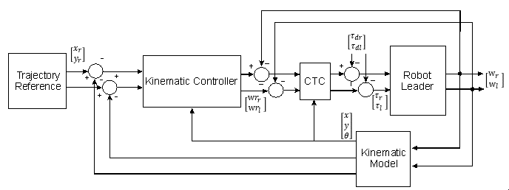

Fig. 1. Control of the Leader Robot
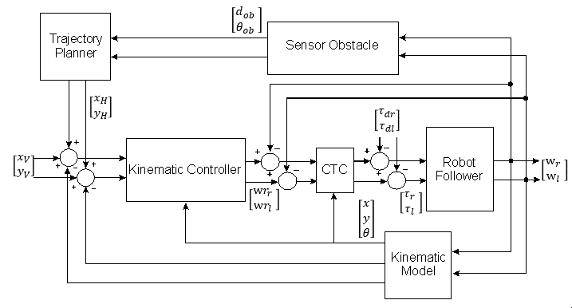
Fig. 2. Control of the Follower Robot
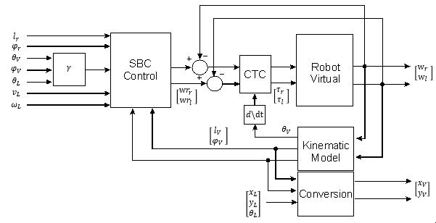
Fig. 3. Control of the Virtual robot
The combination virtual structure and leader-follower approach is shown in Fig. 1,2, and 3 which are leader robots (RL), follower robots ($RF_{1}$, $RF_{2}$), and virtual robots (RV₁, RV₂).

Dynamics Controller
The dynamics model of leader robots (RL) and follower robots (RF) are given as follows :
$$\overline{M}\left(q\right)\dot{η}+\overline{V}\left(q,\dot{q}\right)η=\overline{B}\left(q\right)τ_{F}+τ_{d}$$ | (1)
where $τ_{d}$ is disturbance. Model for virtual robots (RV) are used (1) by ignoring disturbance factor.
The dynamic controller is designed using CTC as follows:
$$τ_{L}={\overline{B}}^{-1}\left(\overline{M}\left(q\right)\left[K_{r}\dot{η}+K_{p}e+K_{i}\int{e}dt+K_{d}\frac{de}{dt}\right]+\overline{V}\left(q,\dot{q}\right)η\right)$$ | (2)
where $e$ is error velocities.
To compensate the disturbance in (1), the disturbance estimation, $τ_{es}$, is added to (2) as follows:
$$τ_{F}={\overline{B}}^{-1}\left(\overline{M}\left(q\right)\left[K_{r}\dot{η}+K_{p}e+K_{i}\int{e}dt+K_{d}\frac{de}{dt}\right]+\overline{V}\left(q,\dot{q}\right)η-τ_{es}\right)$$ | (3)
with

$$τ_{es}=α+β$$  $$\dot{α}=L\left(\overline{V}\left(q,\dot{q}\right)η-\overline{B}\left(q\right)τ-{\overline{τ}}_{d}\right)$$  $$β=C*η$$  $$L\left(q\right)=C\overline{M}{\left(q\right)}^{-1}$$ | (4)
is the observer gain. where $L\left(q\right)$

Formation control and Robot Virtual Kinematic Controller Design
Kinematic controller are design based on SBC approach for formation control between RL-RV and IOL for each robot in formation. The SBC approach which is an $l-φ$ control will be used as a method to adjust each virtual robot (RV) to the follower robot (RL) as shown in Fig. 4
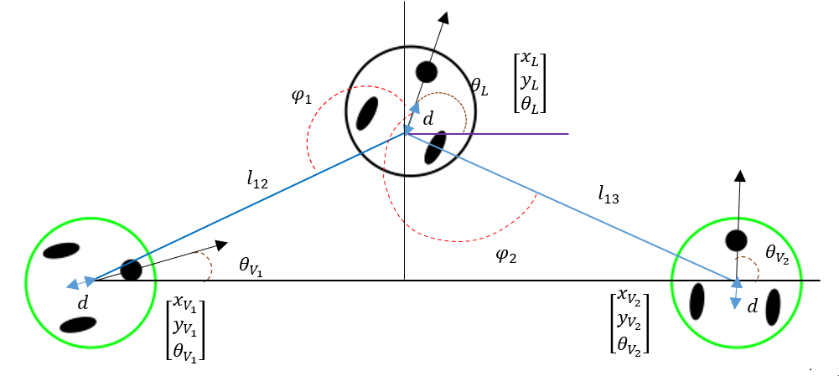
Fig.4 SBC approach
The equations of $l$ and $φ$ can be expressed as:

$$l=\sqrt{{\left(x_{L}-x_{V}-d\cos{θ_{V}} \right)}^{2}+{\left(y_{L}-y_{V}\right)}^{2}}$$ | (5)
$$φ=π-atan2\left(y_{V}+d\sin{θ_{V}}-y_{L},x_{L}-x_{V}-d\cos{θ_{V}}\right)-θ_{L}$$ | (6)
The derivative of (5) and (6) can be written as:
$$\dot{l}=v_{V}\cos{γ}-v_{V}\cos{φ}+ω_{V_{12}}d\sin{γ}$$ | (7)
$$\dot{φ}=\frac{v_{L}\sin{φ}}{l}-\frac{v_{L}\sin{γ}}{l}+\frac{ω_{V}d\cos{γ}}{l}-ω_{L}$$ | (8)
with
$$γ=θ_{L}-θ_{F}+φ$$ | (9)
where $ω_{L}={\dot{θ}}_{L}$and $ω_{F}={\dot{θ}}_{F}$.
Using IOL, the control input of RV₁ and RV₂ can be obtained as shown in (10).
$$\left[\begin{matrix}v_{V} \\ ω_{V}\end{matrix}\right]={\left[\begin{matrix}\cos{γ} & d\sin{γ} \\ -\frac{\sin{γ}}{l} & \frac{d\cos{γ}}{l}\end{matrix}\right]}^{-1}\left(\left[\begin{matrix}k_{1}\left(l^{r}-l\right) \\ k_{2}\left(φ^{r}-φ\right)\end{matrix}\right]-\left[\begin{matrix}-\cos{φ} & 0 \\ \frac{\sin{φ}}{l} & -1\end{matrix}\right]\left[\begin{matrix}v_{L} \\ ω_{L}\end{matrix}\right]\right)$$ | (10)
where $k_{12}$ is constant gain.

Leader and Follower Kinematic Controller Design
Kinematic controller is used to generate robot velocity which can be writen as follows:
$$\left[\begin{matrix}v_{L} \\ ω_{L}\end{matrix}\right]={\left[\begin{matrix}\cos{θ_{L}} & -d\sin{θ_{L}} \\ \sin{θ_{L}} & d\cos{θ_{L}}\end{matrix}\right]}^{-1}\left[\begin{matrix}{\dot{x}}_{r}+k_{L}\left(x_{r}-x_{L}\right) \\ {\dot{y}}_{r}+k_{L}\left(y_{r}-y_{L}\right)\end{matrix}\right]$$ | (11)
$$\left[\begin{matrix}v_{F} \\ ω_{F}\end{matrix}\right]={\left[\begin{matrix}\cos{θ} & -d\sin{θ} \\ \sin{θ} & d\cos{θ}\end{matrix}\right]}^{-1}$$  $$.\left[\begin{matrix}{\dot{x}}_{V}+{\dot{x}}_{H}+k_{F}\left(x_{V}+x_{H}-x_{F}\right) \\ {\dot{y}}_{V}+{\dot{y}}_{H}+k_{F}\left(y_{V}+y_{H}-y_{F}\right)\end{matrix}\right]$$ | (12)
where $d$ is the distance between the center point of the robot and the midpoint between the right and left wheels, $K_{L}$ and $K_{F}$ are gain constants, $\left(x_{r}, y_{r}\right)$ are the reference trajectory, and $\left(x_{V},y_{V}\right)$ are the RV trajectory. The value of $x_{H}$ and $y_{H}$ will be determined for obstacle avoidance.

Obstacle Avoidance Design
The shape of the obstacle and the sensor measurement area used in this paper is designed as shown in Fig. 5, where the distance of the follower to the obstacle can be calculated when the follower robot (RF) is at a certain radius.When robot is at the measurement radius, sensor will measure the distance and angle from the robot to obstacles as shown in Fig. 6.
The following equation is used to calculate the value of heading robot with respect to obstacle:
$$θ_{ob}=atan2\left(y_{f}-y_{ob}, x_{f}-x_{ob}\right)$$ | (13)
The value of heading measurement will be used to determine the direction of movement robot for avoidance. Then the value of $d_{ob}$ is used to determine the change in the trajectory of the follower robot (RF).
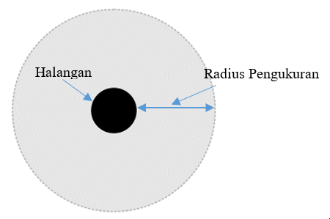
Fig. 5. Obstacle Design and Radius Measurement
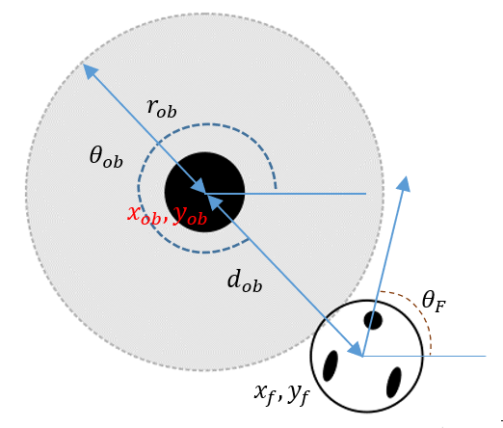
Fig. 6. The Distance and Robot Heading with respect to Obstacle
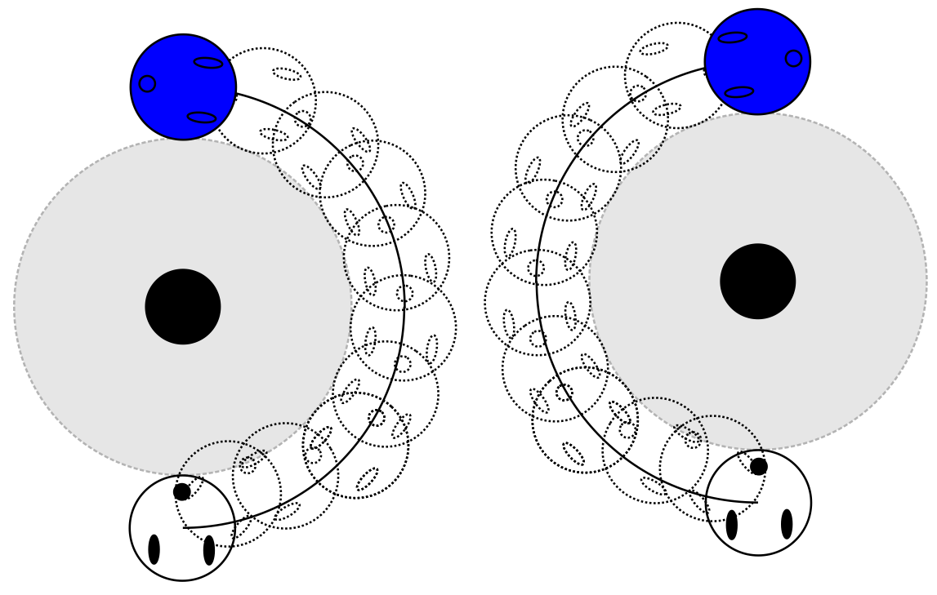
(a) (b)
Fig. 7. Illustration of a Semicircle Trajectory (a) RF₁ and (b) RF₂

Tracking with Semicircle Trajectory
The design of the first trajectory change is a semicircle trajectory The new trajectory coordinates of the follower robot (RF) is given in (16).
$$x_{F}=x_{F}+\left(r_{ob}cos (θ_{ob}±θ_{stl}\right)$$  $$y_{F}=x_{F}+\left(r_{ob}sin (θ_{ob}±θ_{stl}\right)$$ | (14)
where the value $θ_{stl}={10}^{°}, {20}^{°},…, {90}^{°}$. The different between RF₁ and RF₂ is the polarity of the value of $θ_{stl}$. For more details can be seen in Fig 7.
It is shown in Fig. 7 that RF₁ will move to the right every time it detects an obstacle, while for RF₂ it will move to the left. After the follower robot (RF) is in the end position, the reference will change to the trajectory of virtual robot (RV). There will be no collision between followers assuming the tracking error is small or close to zero.

Tracking with Half Square Trajectory
The design of the next trajectory for avoidance obstacle is designed with a half square trajectory. The coordinates of the trajectory are determined by the angle measurement value$,θ_{ob},$ and the heading robot, $θ_{F}$, for example $2π-θ_{ob}-θ_{F}>0°$ and $80°≤θ_{F}≤90°$ .

Simulation and result

Simulation Model using Matlab
In this paper, Simulink and Matlab 2020b 64-bit are used for implementing the design in Chapter III. There are 3 mobile robots and 2 virtual robots used, which are $RL$, RF₁, RF₂, RV₁, and RV₂. The additional 2 virtual robots. as a reference for each follower robots (RF). Each robot has a kinematic controller, a dynamics controller, a robot dynamics model, and a robot kinematics model. Then on the virtual robot (RV) there is a conversion block from $l$ and $φ$ to $xy$ robot.
The robot parameters used are $r=0.025m$, $b=0.1m$, $d=0.05m$, $m_{c}=3kg$, $m_{w}=0.01kg$, $I_{c}=1.5625kgm^{2}$, $I_{w}=0.0005kgm^{2}$, and $I_{m}=0.00025kgm^{2}$. For the SBC formation parameter, the reference value used for $RV_{1}$ is $l=0.7745$ and $φ=2.356rad$ then for $RV_{2}$ is $=0.7745$ and $φ=3.926rad$.

Tracking on 8-shaped Reference
This test was carried out without any disturbance and the plants used were (1) and (2). For kinematic controllers from $RL$, $RV$, and $RF$ used (10)$-$(12). The search for gain parameters used in the experiment was carried out by trial and error. The gain parameters are kinematic controller gain including $K_{L}$, $K_{V1}$, $K_{V2}$, $K_{F1}$, and $K_{F2}$ and dynamic controller gain on each robot including $K_{r}$, $K_{p}$, $K_{d}$, and $K_{i}$.
For the first test, the parameters from trial and error were selected, namely $K_{L}$=120, $K_{pL}$=70, $K_{dL}$=0.48, $K_{iL}$=800, and $K_{rL}$=0.14 and the step size sample time used in Simulink is 0.01s. In this test, the speed of the right and left wheels is limited to a value of $±$100rad/s or 2.5m/s with $r$=0.025m.
The results of the kinematic error of leader robot (RL) error values obtained by both $e_{x}$ and $e_{y}$ are quite good with the maximum error value for $e_{x}$ and $e_{y}$ occuring when $t$=0.02s is -1.7$×{10}^{-4}$m. Although there is oscillation, the value is limited, namely$±$0.5$×{10}^{-4}$m.

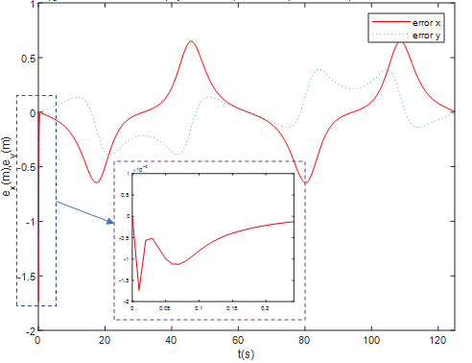
Fig. 8. RL Kinematic Error
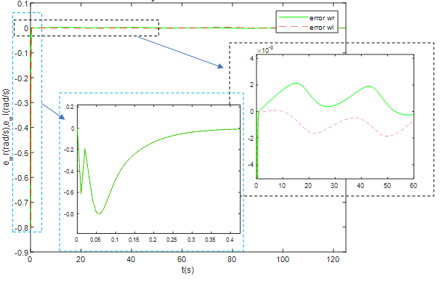
Fig. 9. RL Dynamics Error
The MSE values obtained from $e_{x}$ and $e_{y}$ are very small, around 9.29$×{10}^{-10}$ dan 4.18$×{10}^{-10}$. Because in general the error obtained is quite small, so it is assumed that this criterion is still within the tolerance limit and the desired steady-state error is achieved
Fig. 9. Show the leader robot (RL) dynamics error of the right wheel speed, $e_{wr}$, and the left wheel speed error, $e_{wl}$, with units of rad/s. Then the MSE results are quite small 3.2793$×{10}^{-4}$ and 3.2792$×{10}^{-4}$.The error results oscillations also occur but are still within the tolerance limit with a value of $±$2$×{10}^{-3}$ at steady-state.

SBC Robot Leader dan Virtual Follower Tracking
In next test the parameters used in the RV₁ and RV₂ is $K_{V}$=70, $K_{pV}$=20, $K_{dV}$=0.15 and 0.2, $K_{iV}$=20, and $K_{rV}$=0.99, with the step size sample time used is the same as the previous test, which is 0.01s.
The settling time is 0.0734 on $eV1_{l}$ and 0.0448 on $eV1_{φ}$. This settling time value is quite small because of the influence of the $K_{V1}$ and $K_{pV1}$ gain values used.
By the adjusting $K_{d}$, the peak error value becomes smaller $±$8$×{10}^{-3}m$, so that the overshoot and undershoot can be said to have no significant effect on the kinematic controller output ($w_{r}r$ and $w_{l}r)$. The MSE value obtained is quite small, namely 2.0727$×{10}^{-9}$ on $eV1_{l}$ and 3.5624$×{10}^{-9}$ on $eV1_{φ}$.
For the dynamic error results, namely $eV1_{wr}$ and $eV1_{wl}$ which are obtained, the error signal has a fairly large undershoot, this is influenced by the undershoot of the RV₁ namely RL. However, the maximum error value is not too large, which is -3rad/s. The MSE values are 0.0031 and 0.0102. This value is quite large compared to the MSE value obtained on the RL but this value is still quite good because of the value of the maximum wheel speed is 50rad/s. Because the maximum error value of the right wheel and left wheel speed is less than 6% of the maximum speed value, it can be said that this test shows that the gain parameter selected for RV₁ quite good.
Meanwhile, for the results of kinematic and dynamics errors in the SBC $RL-$RV₂ test, the data obtained is not much different from the SBC $RL-$RV₁ test.
The value of settling time is 0.1103s and 0.0881s while the MSE values are 2.0671$×{10}^{-9}$ and 3.5528$×{10}^{-9}$. The difference between the results of the $RL-$RV₁ with $RL-$RV₂ kinematic errors is not very significant although in general the response on $RL-$RV₁ is better than that of $RL-$RV₂.

Tracking of Robot Follower
In this test, the parameters of $RL$, RV₁, and RV₂ are used the same as the previous test, while the gain parameter for RF₂ is set the same except for $K_{rF2}$ is 0.4. n this test the results to be analyzed are data from RF1 and RF_{2.}
The data from the kinematics error and dynamics RF₁ are shown in Fig. 10 and 11. In the kinematics error error In the kinematic error, the MSE is 8.8935$×{10}^{-9}$ and 6.2992$×{10}^{-9}$ for $eF1_{x}$ and $eF2_{y}$. The MSE values are greater than the results from leader robot (RL) .This is because the reference from RF₁ namely RV₁ experiences overshoot and undershoot at $t<0.03s$ even though the peak error of the kinematic error RF1 is smaller than leader robot (RL) is $-6.7×{10}^{-3}m$. For the settling time value of $eF1_{y}$ is also smaller than $e_{y}$ which is 0.1204s while the settling time of $eF1_{x}$ is greater than $e_{x}.$
In the dynamic error, the settling time and MSE values of RF₁ on average are greater than the results of leader robot (RL) for both $e_{wr}$ and $e_{wl}$ .In this test, the parameter that has the largest is $K_{r}$ both on RF₁ and RF₂. In general, the error obtained from this test is quite good.

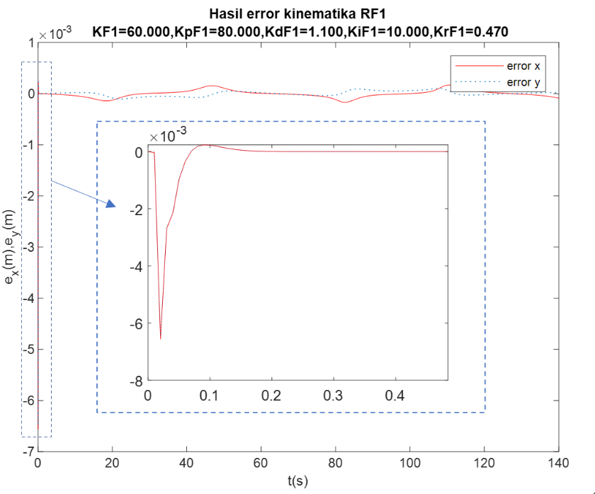
Fig. 10. Kinematic Error Results RF₁

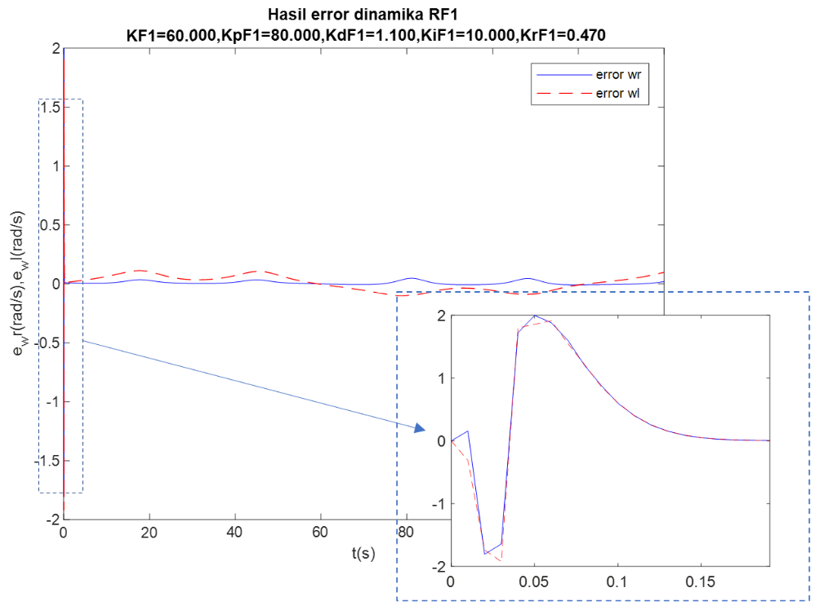

Fig 11. Result of Dynamic Error RF₁

Circle Trajectory Test
This test is carried out without disturbance with the same parameters and criteria used are the same as the previous test. The reference trajectories used are $x=4\sin\left(t/20\right)$ and $y=4\sin\left(t/20\right)$ and initial error $θ_{V1}$ and $θ_{V2}$ are 45$°$.

Fig. 12. RL Kinematic Error Results
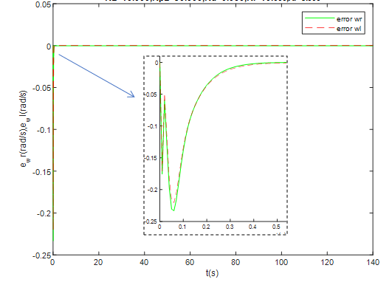
Fig. 13. RL Dynamic Error Result

Tracking Robot Leader Trajectory Testing (Circle Trajectory)
The gain parameters used in this fourth test are $K_{L}$=10, $K_{pL}$=30, $K_{dL}$=0.47, $K_{iL}$=1100, dan $K_{rL}$=0.7. The step sample time value used is 0.01s. The results of the test are shown in Fig. 12-13.
Fig. 12 shows that the kinematic error results obtained are quite good with a peak error of around $±3.1×{10}^{-4}$. The MSE value obtained is quite small, namely 2.9868$×{10}^{-8}$ and 3.4276$×{10}^{-8}$.
With a peak error of less or no more than $±$0.8rad/s as shown in Fig. 23. the speeds of the right and left wheels are within the desired tolerance of $±$100rad/s or 2.5m/s. The value of settling time is 0.3947s and 0.3938s while the MSE values of $e_{wr}$ dan $e_{wl}$ is 2.5$×{10}^{-3}$ and 4.8$×{10}^{-3}$.

SBC Robot Leader and Virtual Follower Testing (Circle Trajectory)
The gain values used in the test are $K_{V}$=30, $K_{pV}$=40, $K_{dV}$=0.1 $K_{iV}$=100, and $K_{rV}$=0.61 for RV₁ and RV₂. he results of the tracking trajectory plots obtained for the SBC arrangement between $RL-$RV₁ and $RL-$RV₂ The kinematic error results from the $RL-$RV₁ and $RL-$RV₂ tests. The criterion value of ${eV}_{x}$ in the $RL-RV_{1}$test is better than the $RL-$RV₂ test for the settling time and MSE while the results of ${eV}_{y}$ on $RL-$RV₂ are better than $RL-$RV₁. For example, the MSE value of ${eV1}_{x}$=1.7474$×{10}^{-10}$ and $eV2_{x}=$1.85$×{10}^{-10}$.
The criterion value of ${eV1}_{wr}$ is better than $eV2_{wr}$ while the value of $eV2_{wl}$is better than $eV1_{wl}$.

Robot Follower Tracking Trajectory on Circle Trajectory
The results of the test tracking trajectory using the gain parameters $K_{F1}$=60, $K_{pF1}$=80, $K_{dF1}$=1.1 $K_{iF1}$=100, and $K_{rF1}$=0.4. In $eF1_{y}$, the data obtained is still not good but the peak error value is still within the desired limit of 2.35$×{10}^{-3}$ as well as the dynamic error results as shown in Fig. 15, the values of $eF1_{wr}$ and $eF1_{wl}$ are quite good.
As for the kinematic error on RF₂ Fig. 16, the value is quite good with the MSE values for $eF2_{x}$ and $eF2_{y}$ respectively 4.4108$×{10}^{-8}$ and 4.1978$×{10}^{-8}$ then MSE for error the dynamics are 8$×{10}^{-3}$ and 8.1$×{10}^{-3}$. From this test, it can be seen that even though the initial error is given at the angle, the speed of the right and left wheels does not exceed the given limit of 100rad/s.

Fig. 14. Kinematic Error of RF₁ Trajectory Tracking

Fig 15. Dynamics Error of RF₁
Fig. 16. Kinematic Error of RF₂

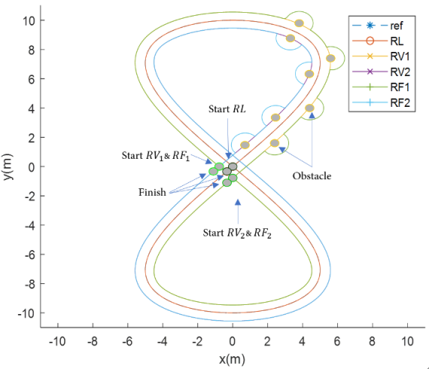

Fig 17. Tracking Trajectory Test Results with Obstacle

Tracking Trajectory with Obstacle Avoidance
There are 8 obstacles in this test, the speed value of the right and left wheels is limited to ±100rad/s. In this test, the initial position error given to the RV and follower is quite small, 0.25m for each robot.
The RF₁ and RF₂ managed to avoid the obstacles given to the path. Fig. 18 and 19 show the kinematic and dynamics results of the error from RF₁.
Whenever the robot detects an obstacle, which is set to 0.8m, the trajectory of RF₁ will change into a semicircle. But because the angle of robot could be different each time it detect obstacles, the trajectory must be adjust to avoid the collision between robots. The results of the kinematic error and dynamics of RF₂ are shown in Fig. 20 and 21. The results of the kinematic error of RF₂ are better than those of RF₁. However, the resulting dynamic error is still not good because it is more than 100rad/s even though the speed of the right and left wheels has been limited to $±$100rad/s.

Fig. 18. Kinematic Error RF₁
Fig. 19. Dynamics Error RF₁
Fig 20. Kinematics Error RF₂
Fig 21. Dynamics Error RF₂

The result of the tracking of a circle trajectory is shown in Fig. 22 which the follower robot (RF) can avoid the given obstacle.
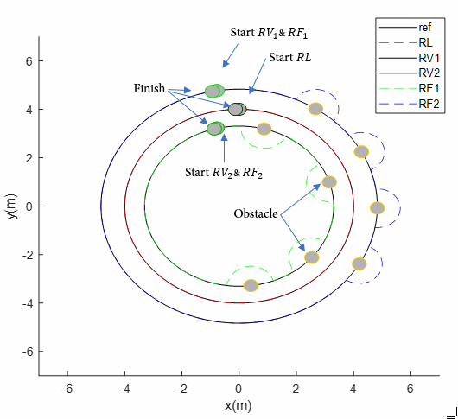
Fig. 22. Tracking Circle with Obstacle

The result of kinematic error is shown in Fig. 23. Although every time robot tracking new reference for obstacle avoidance, there is a rapid change in error but the error reduces to small again. The speed limit for this tracking is limited to 25rad/s.
Fig. 23. Kinematic Error RF₁
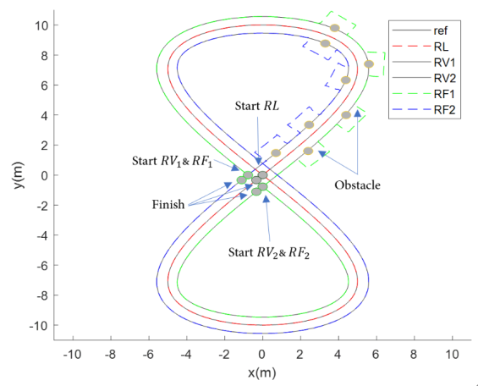
Fig. 24. Semisquare Reference for Obstacle Avoidance
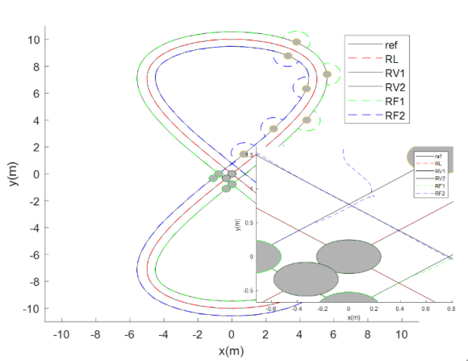
Fig. 25. Tracking with Obstacle and Disturbance

Tracking of Circle Trajectory with semi square
The result of the tracking with obstacle avoidance and obstacle disturbance is shown in Fig. 24 and 25. The robot can track the given trajectory but the tracking the error is big so the particularly dynamics error robot. For example, the MSE $e_{wr}=283m^{2}$ of RF₂, which is quite big, and $e_{wl}=8m^{2}$ as shown in Fig. 30. However, using disturbance observer, as shown in Fig. 28-30, the kinematic error in Fig. 29 after avoid obstacle the obstacle become very small compare to kinematic error in Fig. 26.
Fig. 26. Kinematic Error RF₁ of Tracking with Obstacle and Disturbance
Fig. 27. Dynamic Error RF₁ of Tracking with Obstacle and Disturbance
In this test, can be seen the different when disturbance observer is used to reduce the effect of the disturbance, although the error in each tracking reference for obstacle avoidance stay the same but overall performance of the controller is good based on the achieved desired target.
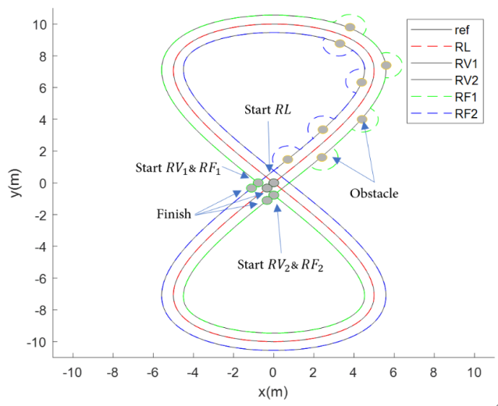
Fig. 28. Tracking with Obstacle and Disturbance with Disturbance Observer
Fig. 29. Kinematic Error RF₂ of Tracking with Obstacle and Disturbance
Fig. 30. Dynamics Error RF₂ of Tracking with Obstacle and Disturbance with

Conclusion
The simulation result show that the proposed method can be used to solve obstacle avoidance problem on trajectory tracking of formation control. When there are no obstacles, the formation can be formed very fast and maintained with small kinematic and dynamics error results. Although there is variation of criteria performance values, both in circle and 8-shaped trajectory, the good tracking performance is achieved. With the present of obstacles, kinematic and dynamics error values change rapidly every time the follower robot avoid the obstacle particularly in the start of the trajectory change but within the desired value. For the disturbance system problem, with disturbance observer, the result of trajectory tracking in both trajectories is very good where The MSE value of${ eRF_{1}}_{x}$ is$7.704×{10}^{-5}$ and $eR{F_{1}}_{y}$ is $4.4601×{10}^{-5}$ this value is quite small, but with the increase in the error previously mentioned, the dynamic error values $eR{F_{1}}_{wr}$ and $eR{F_{1}}_{wl}$ also become larger with MSE of 4.4687 and 4.7543. However, when the measurement disturbance (white noise) is given, the dynamics error is big in beginning of tracking, although just in short period, the gain tuning method is needed. Thus, the development of the formation approach and controller can be used for trajectory tracking with obstacle avoidance and disturbance problem in formation control.

[1] | References  B. A. Issa and A. T. Rashid, “A Survey of Multi-mobile Robot Formation Control,” International Journal of Computer Applications, vol. 181, no. 48, p. 0975 – 8887, 2019.
[2] | M. Ghiasvand and K. Alipour, “Formation control of wheeled mobile robots based on fuzzy logic and system dynamics,” Fuzzy Systems (IFSC), 2013 13th Iranian Conference, p. 1–6, 2013.
[3] | S. Ahmed, M. N. Karsiti and R. N. K. Loh, “Control Analysis and Feedback Techniques for Multi Agent Robots,” INTECH Open Access Publisher, 2019.
[4] | A. Kusumawardana and T. Agustinah, “Disturbance Compensation Using CTC with NDOB for Formation Control Mobile Robots,” International Conference on Information and Communications Technology, 2018.
[5] | Arfittariah and T. Agustinah, “Formation Control of Multi-Robot using Virtual Structures with a Linear Algebra Approach,” JAREE (Journal on Advanced Research in Electrical Engineering), 2020.
[6] | Z. Ying and L. Xu, “Leader-follower Formation Control and Obstacle Avoidance of Multi-robot Based on Artificial Potential Field,” IEEE Chinese Control and Decision Conference (CCDC), 2015.
[7] | A. Abbaspour, S. A. A. Moosavian and K. Alipour, “A Virtual Structure-based Approach to Formation Control of Cooperative Wheeled Mobile Robots,” RSI/ISM International Conference on Robotics and Mechatronics, 2013.
[8] | S. Xiao, L. Feng, H. Lian and B. Du, “Dynamic Formation and Obstacle Avoidance Control for Multi Robot System,” World Congress on Intelligent Control and Automation (WCICA), pp. 59-63, Juni 2016 .
[9] | R. Dhaouadi and A. A. Hatab, “Dynamic Modelling of Differential-Drive Mobile Robots using Lagrange and Newton-Euler Methodologies: a Unified Framework,” Advances in Robotics & Automation, vol. 2, no. 2, pp. 1-7, 2013.

