Deep Learning-based Decision Support System for classification of COVID-19 and Pneumonia patients

Misha Urooj Khan
Department of Electronics Engineering
University of Engineering and Technology (UET)
Taxila, Pakistan
mishauroojkhan@gmail.com
Zeeshan Abbasi
Department of Electronics Engineering, University of Engineering and Technology
Taxila, Pakistan
18-ENC-33@Students.uettaxila.edu.pk
Zubair Saeed
Department of Computer Engineering
University of Engineering and
Technology Taxila
Pakistan
zubair.saeed@students.uettaxila.edu.pk

Syeda Zuriat-e-Zehra Ali
Department of Electrical Engineering University of Engineering and Technology
Taxila Pakistan syeda.zuriat@students.uettaxila.edu.pk
Ali Raza
Department of Computer Engineering
University of Engineering and
Technology (UET)
Taxila, Pakistan
ali.raza6@students.uettaxila.edu.pk
Hareem Khan
Department of Computer Engineering
University of Engineering and
Technology (UET)
Taxila, Pakistan
hareem.khan5410@gmail.com

Abstract— The fast spread of Coronavirus (COVID-19) poses a huge risk to people all around the world. Recently, COVID-19 testing kits have been unavailable due to rise in effected people and large demand of tests. Keeping the urgency of the situation in mind, an automatic diagnosis method for early detection of COVID-19 is needed. The proposed deep learning decision support system (DSS) for COVID-19 employs MobileNet v2 Deep learning (DL) model for effective and accurate detection. Here we collected Cough auscultations through self-designed digital sensor. The primary experimental results show that the maximum accuracy for training is around 99.91%, and the maximum accuracy for validation is 98.61%, with 97.5% precision, 98.5%recall, and 98% F1-score. The Deep Learning-based model described here strives for similar performance to medical professionals and can help pulmonologist/radiologists increase their working productivity.
Keywords—COVID-19, Cough auscultation, Decision support system, Deep learning, MobileNet v2, Pneumonia.

Introduction
The deadly Covid-19 virus first apprised in Wuhan, China in December 2019 has caused severe devastation all around the world by affecting the global population. On 11th March 2020, the World Health Organization (WHO) has declared this deadly Covid-19 as a global pandemic which brought the world to a standstill [1]. According to WHO statistics, more than 5 million fatalities have been caused by Severe Acute Respiratory Syndrome Corona-Virus 2 [2]. Pathomorphological alterations in the respiratory systems are caused by this deadly and chronic virus. Experimental analysis has proved that it can be regarded as an airborne disease that can spread via droplets from person to person and as a result of surface contamination [3]. Persons above the age of seventy-five have weak immune systems and they are more likely to be affected by this virus as compared to young people [4]. Health organizations all around the world are looking to explore new techniques and technology to mitigate this international health crisis. The latest techniques based on Artificial intelligence (AI) and machine learning (ML) are vital to detect the presence and growth rate of this virus. Even the probability of patient’s death can be calculated by experimentation and analyzing the already existing data of previous patients using Artificial Intelligence. Such techniques are highly crucial in battling this deadliest of all viruses. Similarly, Pneumonia is a very common lungs disease that is caused by the Influenza virus and demands an accurate diagnosis at the outset to receive proper treatment [5].
The state of the human respiratory system can easily be observed by experimenting the respiratory sounds. Auscultation with various wearable devices has been one of the most widely used, low-cost, and simple approaches for detecting respiratory infections early. Pneumonia kills an estimated 1.3 million children under the age of five, and many newborns are also affected by pneumonia, putting their lives in jeopardy. If these events are diagnosed and reported on time, the percentage of deaths can be kept to a minimum [6-7] Patients of Covid-19 and Pneumonia have some identical and comparable symptoms like fever, tiredness, and dry cough. Hence, a highly efficient algorithm is required for the successful categorization of these two diseases.
The health industry is looking for highly effective, non-invasive tools and approaches to diagnose and manage the spread of the coronavirus outbreak and distinguish it from other diseases. Artificial intelligence (AI) is one of the most essential uses of global technology right now since it can monitor and anticipate the rate of growth of the coronavirus, as well as identify the risk and morbidity of Coronavirus patients. Coughing is a common defense mechanism that aids in the clearing of the respiratory tract and prevents hazardous substances from entering the respiratory system. One of the primary symptoms of COVID-19 is a dry cough accompanied by a high body temperature, and it may therefore be utilized to identify the virus.
In medical image analysis, Computer-aided diagnosis and Artificial Intelligence are recognized as useful tools. Deep learning algorithms like Convolutional Neural Network (CNN) can also provide efficient and expert recognition of patterns in sounds or images by eliminating the need for segmentation and pre-processing techniques. Such CNN approaches based on deep learning architecture are broadly used for visual recognition tasks [8]. Transfer learning can also be defined as a technique that enhances the self-learning capacity of CNN which can result in higher classification accuracy. ​The key advantage of using the Transfer Learning Technique is that it can utilize a very smaller dataset and provide highly efficient and accurate classification results. Now, many preliminary medical diagnostic methods are invented by the application of deep learning algorithms to identify the ailments in Chest X-rays, Computed tomography (CT) scan, Cough sound patterns, and ultrasounds [9-11].
The use of X-rays in image analytics is gaining traction, as image categorization for neural network training is based on them [10]. X-rays can also provide patient characteristics and particular including gender, bone age, and illnesses [9]. Medical image analysis for early detection and diagnosis using chest X-rays, CT scans, and ultrasound has grown in popularity during the last two decades [32]. Given the high-resolution image acquisition of these radiological apparatuses, deep-learning has been identified as the best method for the categorization of medical pictures obtained from them [9, 12]. Cough sounds have been used in multiple investigations for sound-based medical diagnosis of Covid-19 [11, 13-16]. Manual methods of capturing and diagnosing respiratory sounds are used by medical workers. Manual testing for medical diagnosis is neither practical nor safe in a pandemic scenario, considering the large number of individuals who could be viral carriers [17].
Substantial advancements toward the detection of Covid-19 and other pulmonary diseases have been made by the integration of Artificial based Machine learning (ML) and Deep Learning (DL) methods. Majorly, Researchers have used DL and ML methods for noninvasive detection of Covid-19 to protect the medical workers from getting any sort of infection. It is really important to detect these diseases at an early stage to mitigate their hazardous effect and further spread among other people as well. Adopting this prime objective, we have used an auscultation sensor for data acquisition of Covid and Pneumonia cough signals. We have applied the transfer learning approach and deep learning MobileNet v2 for the detection and classification of Pneumonia and Covid-19.

Literature Review
COVID-19 has progressively expanded over the world, affecting people's lives, public health, and financial systems in a variety of countries on a daily basis. An efficient and unique algorithm was proposed by Misha et al. [18] for diagnosing COVID-19 illness from cough auscultations. A dataset consisting of 1579 cough auscultations (CA) was self-collected. The data were treated by eliminating dc components and normalizing the amplitude. The Hjorth descriptor was used to extract activity, mobility, and complexity aspects from pre-processed and segmented data. The system achieved an accuracy of 99.8% with a Medium K-nearest neighbor (KNN) classifier and 94.9% with a Fine Decision tree classifier. In [19] a smart system for identifying viruses based on breath sounds was developed as breath sounds reveal a lot about the status of a person's respiratory system. After preprocessing and extraction of features, the KNN classifier was trained with an accuracy of 99.4%. Detecting disorders using lung sound analytics and non-invasive methods is a difficult task. A ML framework for distinguishing asthmatic and non-asthmatic patients was developed by Misha et al. [20]. The signal was first denoised and segmented using normalization and empirical mode decomposition (EMD) algorithms. Mel-frequency Cepstral Coefficients (MFCC) and Gammatone Cepstral Coefficients (GTCC) were used to combine cepstral properties. After experimenting on the Raspberry Pi, an ensembled bagged tree classifier with an accuracy of 97.4% on selected fused features demonstrated improved performance. A COVID-19 cough and breath analysis based on deep learning techniques was proposed in [21] that can distinguish COVID-19 and healthy cough/breaths collected from wearable sensors. Firstly, the noise was removed and then the deep Long Term Short Memory (LSTM) model was used to extract deep features. Finally, the audio features were extracted in the recognition phase. Another deep learning method was developed in [22] to diagnose normal and covid cough from the publicly available cough dataset. This resulted in a precision of 94%, indicating that a stronger cough dataset is required to continue the research on a much larger scale.
The chest CT has been considered as the first line of defense in the diagnosis and surveillance of COVID-19 infection. Ziwei Zhu et al. [23] presented a COVID-19 infection testing diagnosis prototype system. The proposed model based on deep learning is developed and tested on 2267 CT sequences from 1357 COVID-19-positive patients and 1235 CT sequences from non-infected people. Using ResNet50 architecture, it was found that the classification results for COVID-19 and non-COVID-19 with the joint detection of reverse transcription polymerase chain reaction (RT-PCR) and CT as ground truth, were 93% and 85% respectively. The early diagnosis of new coronavirus pneumonia (NCP) using chest computed tomography (CT) has been demonstrated in this study by Min Zhou et al. [24]. An integrated deep learning framework was created based on chest CT scans for the automatic identification of NCP, with a specific focus on distinguishing NCP from influenza pneumonia (IP). With an area under the curve (AUC) of 0.93, the Trinary scheme accurately discriminated NCP from IP lesions. Halgurd et al. [25] compiled a large dataset of X-rays and CT scan pictures from a variety of sources and developed a simple but effective COVID-19 detection method based on deep learning and transfer learning methods using CNN and a pre-trained AlexNet model with 98 % and 94.1% accuracy respectively. Wheezing is a common symptom of pulmonary diseases such as asthma and pneumonia. The identification of wheeze sound in asthma and pneumonia patients is done in using breathing sounds. Signal processing and machine learning techniques are used in the study. It contains normalization-based pre-processing, filtration-based denoising, segmentation to remove non-breathing and quiet sections, spectral-domain feature extraction, and support vector machine classification (SVM). The accuracy of the system was more than 96% [26].
The CT scans were evaluated using the uAI Intelligent Assistant Analysis System in [27]. In COVID-19 patients, a chest CT paired with analysis by the uAI Intelligent Assistant Analysis System can reliably diagnose pneumonia. Dry cough is the most prevalent symptom of Mycoplasma pneumonia, unusual bacterial pneumonia. By using numerous deep learning approaches such as ResNet-18 and MobileNet-v2 architectures on CT images for classification of mycoplasma pneumonia, typical viral pneumonia and COVID-19 was done [28]. The usage of contemporary deep learning models (VGG16, VGG19, DenseNet201, Inception ResNet V2, MobileNet V2, Resnet50, and Inception V3) to cope with coronavirus pneumonia detection and classification is compared [29]. Confusion matrices were utilized to evaluate model performance using a chest X-ray and CT dataset. In comparison to previous models employed in this study, the employment of inception Resnet V2 and Densnet201 produced better results. By ejecting the last five layers of Resnet50 and adding 10 layers the hybrid architecture for detecting Covid-19 was created by authors in [30]. In the hybrid model, the number of layers were increased from 177 in the Resnet50 architecture to 182. By using the hybrid architecture 96.30% accuracy rate was achieved. The authors in [31] designed and evaluated an integrated deep learning framework for auto-detection of NCP utilizing chest CT scans, with a focus on distinguishing NCP from influenza pneumonia (IP). An accurate early diagnosis tool for NCP on chest CT with high transferability, as well as high efficiency in distinguishing NCP from IP, reducing misdiagnosis, and containing pandemic transmission was achieved. Moutaz Alazab et al. [32] described an AI based deep CNN to detect COVID19 patients using real-world datasets. They examined chest X-ray scans as X-rays are readily available and inexpensive, their findings suggest that such an approach is useful in COVID-19 diagnosis.
- Copmarsion of Previous Studies
Reference | Dataset | Data Form | Technique | Results
[18] | Self-Collected Dataset  Covid-19 Cough: 393  Wet Cough: 570  Dry Cough: 616 | Cough Sounds | Machine Learning  Medium-KNN and Fine Decision Tree classifiers | Accuracy:  99.8% and 94.9 %
[21] | Open Source  Train set (sick (n=1435), not_sick (n=2283)),  Validation set (sick (n=468), not_sick (n=753))  Test set (sick (n=642), not_sick (n=1012) | Cough Sounds | Deep Learning  Deep Long Term Short Memory (LSTM) model | Accuracy: 80.26%
[22] | Open Source  8 COVID hack tests, 28 pneumonia, 15 pertussis, and 30 typical hack sounds. | Cough Sounds | Machine Learning (SVM)  Deep Learning (LSTM) | Accuracy: 94%
[23] | Huangpi Hospital of Traditional Chinese Medicine Covid-19: 1357  Normal: 1235 | Chest CT Images | Deep Learning (ResNet50 architecture) | Accuracy:  Covid-19: 93%  Non-Covid-19: 85%
[24] | Novel Coronavirus Pneumonia: 148+57=205  Influenza Pneumonia: 194+50=244 | Chest CT Images | Deep Learning (VGGNet) | AUC: 0.93
[25] | Covid-19  Xray: 170  CT: 356 | X-ray and CT Images | Pre-Trained CNN Model, AlexNet Model | Accuracy:  Pre-trained: 98%  Modified CNN: 94.1%
[28] | Mycoplasma Pneumonia: 83  Typical Viral Pneumonia: 58  COVID-19: 184 | Chest CT Images | Deep Learning Models | AUC:  ResNet-18: 0.93  MobileNet-v2: 0.90
[29] | Bacterial Pneumonia: 2780  Coronavirus: 1493  Covid-19: 231  Normal: 1583 | Chest X-Ray and CT | Deep Learning Models | Accuracy:  Inception-ResNetV2: 92.18%  Densnet201: 88.09%
[30] | Covid-19: 136  Pneumonia: 245  Normal: 162 | Chest X-Ray Images | Deep Learning Models (AlexNet, ResNet50, GoogLeNet, VGG16),  Hybrid ResNet50 | Accuracy:  96.30%

Research gap and questions
Previous research investigated X-ray and CT scans, but the performance of the models that utilized them was inadequate owing to a lack of a sufficient number of images per category in datasets. To close this research gap, our study focuses on constructing a deep learning model to detect COVID-19 using a low-cost self-designed digital sensor with Mobile net v2 based DSS that outperforms existing methods in the literature. This paper addresses the following research questions (RQ):
- RQ1: Can a self-designed digital sensor acquire good lung sounds/audio/cough/acoustic data?
- RQ2: Can we propose deep learning decision support system model that outperform those that have already been published in literature?

Paper Contribution & Novelty
Most of the work done in literature addressed detection of COVID-19 and pneumonia using Chest Xray and CT scans. These two methods are quite expensive from the monetary point of view and their results take some time. Also, during an X-ray the radiations harm and damage body tissues. In the market, Littman and other digital stethoscopes cost about PKR 100,000 plus, which is a very high price to be paid. That’s why we developed a low-cost sensor that can excellently capture cough sounds and convert them to digital form without any information loss. Following are the most significant contributions of this paper.
- Review of the most recent COVID-19 AI-based detection methods.
- Development of a low-cost digital cough auscultation sensor
- Data collection of pneumonia and COVID-19 patients from January to December 2021, Pakistan.
- A detailed discussion of the proposed multiclass classification methodology for categorizing dataset instances based on the two categories: (1) Coughs caused by pneumonia and (2) COVID-19.
- Optimization of Mobilenet v2 using transfer learning approaches, resulting in high classification performance metrics as compared to literature.
- Detailed performance evaluation of the proposed model, as well as a comparison with existing classification methodologies.
The novelty of this paper is that we collected dataset for covid and pneumonia patients locally by designing a low-cost digital stet.

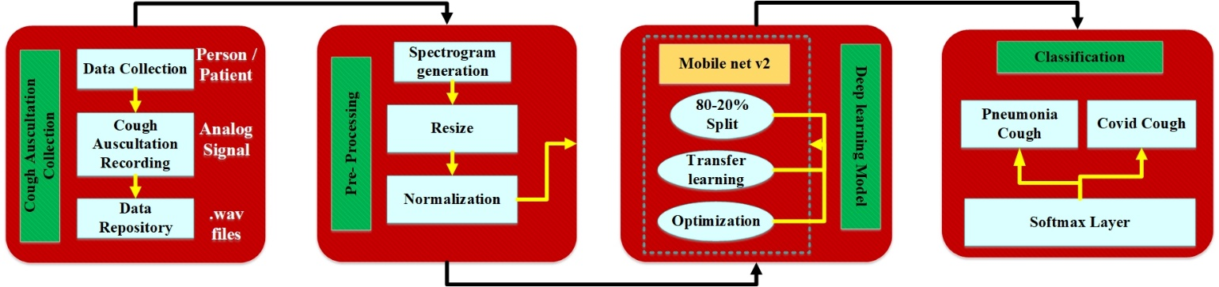
- Proposed Block Diagram of Deep Learning-based Decision Support System.
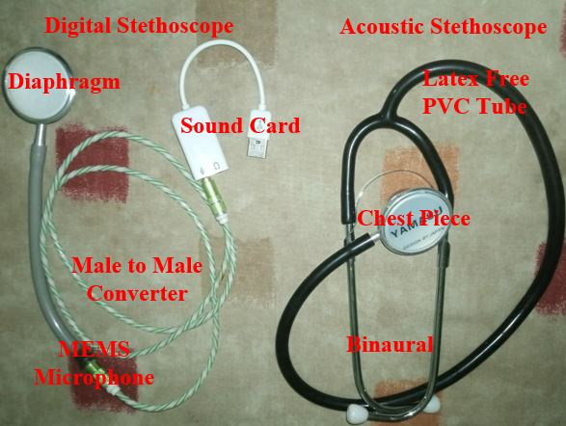
- Self-Designed Sensor [18-20,44].
- Self Collected Dataset Statictics
Cough Auscultations | Female Subjects |  |  | Male Subjects |  |  | Total
Cough Auscultations | Female | Samples | Age | Male | Samples | Age | Total
COVID-19 | 200 | 2000 | 18-61 | 205 | 2061 | 21-74 | 4061
Pneumonia | 146 | 1469 | 13-66 | 150 | 1500 | 5-89 | 2696

Research Methdology
COVID-19 has severe side effects on the health of human beings and causes death. It has quite the same symptoms as pneumonia cough so we need a decision support system that can differentiate between COVID-19 and pneumonia coughs. Recent advancements in the deep learning approaches bought resolution in the detection and classification that provide more accuracy without hand-crafted features. Fig. 1 shows the proposed methodology of our system. We used a CNN-based deep learning model named MobileNetV2 for the detection and classification of covid and pneumonia-coughs.

Dataset Acquisition and Distribution
Coughs and other vocal sounds carry pulmonary health knowledge that may be utilized for COVID diagnosis because new investigations have revealed the existence of nonlinear processes in these signals. That’s why on evidence present in literature, we can say that sound/cough sounds/signals can help us detect Covid and pneumonia successfully [33-35].
Here, we acquired a self-collected dataset using a self-designed sensor named Auscultation Sensor (AS) as shown in Fig. 2. The AS includes a stethoscope, sensitive microphone, sound card, and laptop. AS was placed on the backside of the thorax region where lungs are located. The diaphragm of steth sensed cough auscultations (CA), which were transmitted to a sound card by the microphone. Sound card converted oncoming analog signals to a digital ones and in computer, a python program was running which saved these digital signals as .wave file.
The time duration of the collection of this dataset spans from January 2021 to December 2021. All CA’s were collected at daytime with a sampling rate of 44.1k Hz, 8-bit rate, and mono channel. We gathered CA’s from pneumonia and covid patients. Pneumonia patients were screened from local hospitals while the COVID-19 patient's dataset was acquired from nearby local residents whose nose/mouth swap test came as COVID-positive. Before data collection, each covid patient test report was seen for confirmation. Total 346 female and 355 male subjects participated in this study. A single recording lasted up to 5 sec and from each subject 10 sec10 recording was aken. All recordings of both categories were saved as DISEASES_SUBJECT NO_AGE_GENDER.wav.
Detailed dataset information is given in Table II. Fig. 3 (a) shows the CA’s obtained from covid and pneumonia patients. Visually it can be seen that their amplitude range is the same. Covid cough shows sharp peaks after regular time intervals, while pneumonia cough has continuous transmission. Fig. 3 (b) shows the CA in frequency domain. COVID-19 cough spectrum range is from 0-16 kHz while Pneumonia Cough is from 0 to 15kHz. Thus, both signals are visually differentiable in both time and spectrum domain, for now.
- Raw Signal Obtained from Cough Ascultation sesnor (a) Time Domain (b) Frequency Domain.

Pre-Processing
Following pre-processing steps are taken before giving input to the chosen deep learning model.

Spectrograms Generation
Raw audio is almost never used as input for deep learning models. Audio is frequently transformed into a spectrogram. The spectrogram provides a succinct "snap" of an audio waveform, and because it is an image, it is perfect for feeding into CNN-based image-based models. To create spectrograms from cough signals, Fourier Transforms are utilized. A Fourier Transform breaks down an input into its fundamental frequencies and illustrates the magnitude of each. It breaks a sound source's duration into smaller time segments before applying the Fourier Transform to each segment to detect the frequencies contained within that segment. All of the Fourier Transforms for those segments are then integrated into a single graphic. That’s why raw cough dataset is converted into respective spectrograms because deep learning performs best when the input given to them in image form. Each cough sample is captured with a window size of 0.25ms, then converted to a spectrogram image wherein the x-axis contains the time of the sample and the y-axis amplitude of the frequencies against each time-space and finally these visuals are saved as .png format as shown in Fig. 4.
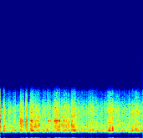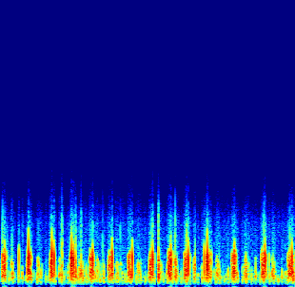
- Generated Spectrograms (a) Pneumonia (b) COVID.

Resize
Each spectrogram has a size of 400x400 during conversion. It was resized to 224x244 which is the required dimension of MobileNetV2, as shown in Fig. 5.
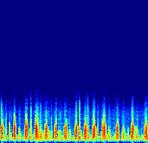
- Resized Spectrograms (a) Pneumonia (b) COVID.

Normalization
After resizing the spectrograms, all pixels are normalized. Pixel values have a range of 0 to 256 depending upon the intensity value of the pixel which has normalized into respective values. Mathematically,
${Spectrogram}_{Norm}=\frac{Pixel-Value}{256}$ (1)

Transfer Learning
Transfer learning is a machine learning approach in which a model that has been built for a task is utilized again as the reference basis for a second task model as shown in Fig. 6. In this article, we utilized a trained base network on a dataset (ImageNet [36]) and a task (classification of 1000 classes), and then reassigned or transferred the learning characteristics to a second smaller target network to be trained in a desired dataset (self-collected) and task (cough detection and disease classification). Utilization of this approach succeeded for the classification of cough because the models were trained on generic attributes of 1000 classes, which means that they are suited for both the base and the target tasks classification [37].

MobileNet-V2 Deep Learning Model
CNN based DL models require a relatively wide range of training parameters [19]. They comprise alternating convolutional layer-CL (performs feature extraction) and pooling layers-PL (reduces extracted features) with fully linked layers. CL is supported by n filters where k is less than the incoming dimensions and q is typically different for every kernel. Here, we selected CNN based MobileNet-V2 deep learning model for COVID + pneumonia detection and classification [38-39].

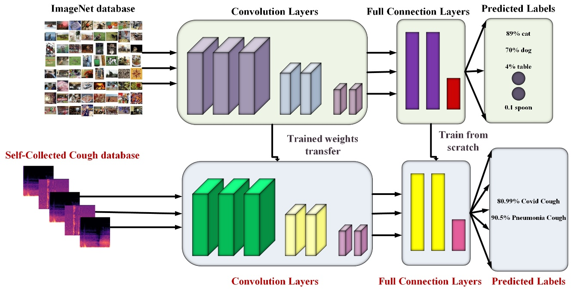
- Block Diagram of Transfer learning Approach.
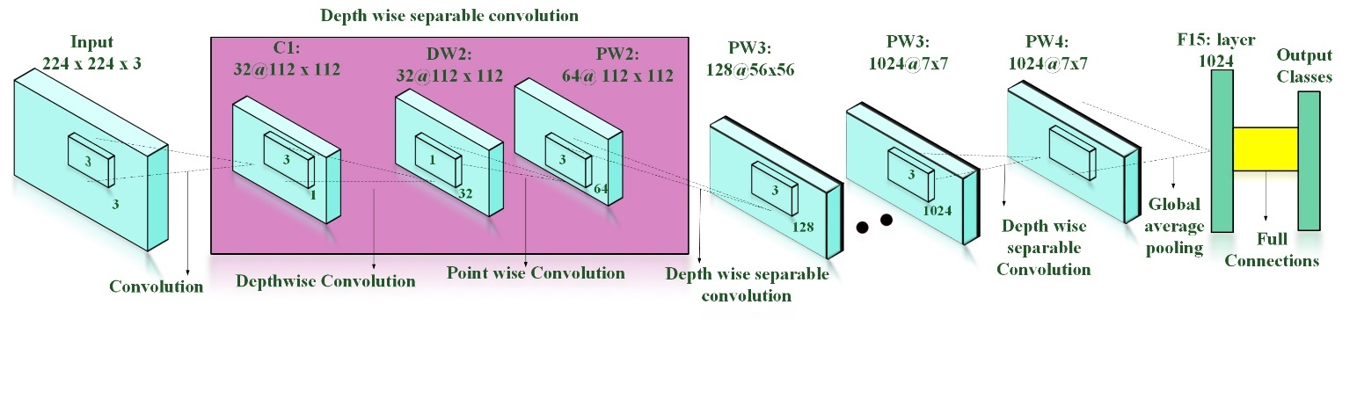
- Architecture Diagram of MobileNetV2 Deep Learning Model [38].

The block diagram of MobileNet-V2 is shown in Fig. 7.

Architecture: MobileNetV2 uses fully separable convolution as efficient components. It includes two new architectural elements,

linear bottlenecks across the layers.

shortcut connections between the bottlenecks.
With approximately 350 GFLOP, the MobileNetV2 contains 53 convolution layers and 1 AvgPool. It is made up of two major parts:
- Residual Block inverted
- Residual Bottleneck Block
And uses two types of Convolution layers:
- Convolution 1x1
- Depth-wise Convolution 3x3
Bottlenecks indicate the model's inputs and outputs, whereas the input layer represents the model's ability to transition from lower-level notions (for example, pixels) to higher-level variables (for example categories of images). Finally, shortcuts, like classical residual connectivity, allow for faster training and higher accuracy [38-39].

Transferring MobileNet v2 weights
As seen in Fig. 6, our network training process consists of three major phases.
- To begin, we use a MobileNet v2 model that has been pre-trained on the ImageNet dataset. This training is performed to categorize primary targets using full pictures as input rather than pre-selection attributes. Each picture has one main target that takes up a substantial amount of the image.
- Following that, we load all of the information from the previous six ImageNet-trained layers.
- Finally, after adjusting the settings of the different number of layers, we fine-tune on the self-collected dataset.

Optimization
Optimization is the issue of finding a collection of variables that lead to the assessment of optimum or minimal features for an objective function. This methodology needs continuous function optimization, as there are true numerical values for the input parameters for the function, e.g., floating-point values. The result of the function is also a realistic assessment of the input data. Here, we used Adam optimizer (AO) [40] and gradient descent optimization (GDO) [41] algorithms for optimization in Mobile net v2.

Adam optimizer
AO is works phenomenally and considerably quicker than other methods since its preset hyperparameters generally function perfectly. The gradient is a multivariate continuous objective function's derivative (MCOF). MCOF is a vector, and every component in the vector is referred to as a partial derivative, or the degree of variation for a particular variable at a particular location provided all other variables stay unchanged. It is built on a convex function and continuously modifies its characteristics to reduce a specific task to its regional base level.

Gradient decent
For the gradient decent we repeated the back-propagation until convergence of the best weight. Mathematically, it can be understandable as,
Repeat until convergence
{
$θ_{j} := θ_{j}- α\frac{δ}{δθ_{j}} J(θ_{0},θ_{1},….θ_{n})$ (2)
}
Where $θ_{j}$ is the updated weights after back-propagation, $α$ is the learning rate and $J(θ_{0},θ_{1},….θ_{n})$ is the cost function. Similarly, we have used the Adam optimizer which is fast and robust for the convergence of the beat weights during training and validation. It can be understand using below mathematical form,
Initialize $m_{0}=0 and x_{1}=0$
Repeat for t= 1, 2,…, T
{
$m_{t}= β_{1}m_{t-1}+(1-β_{1})g_{t}$ (3)
$v_{t}=h_{t}(g_{1}, g_{2},…,g_{t})$ (4)
$θ_{t-1}=x_{t}- \frac{α_{t}}{\sqrt{v_{t}}}*m_{t}$ (5)
}
Where $θ$ is the optimized variable, $g_{t}$ is stochastic gradient at step t, $β_{1}$ is a non-increasing sequence $h_{t}$ arbitrary function that outputs a vector having the same dimension as x.

Softmax Layer
The softmax function is used to activate a multidimensional probability distribution in the output layer of neural network models. In reference to Eq 6, the incoming variables can be negative, positive, zero or higher, but softmax converts them to numbers from 0 to 1 to be understood as probabilities. Mathematically,
${Softmax }_{input}=\frac{{exponential function}^{input}}{\sum_{1}^{no.of classes}{{exponential function}^{ouput}}}$ (6)

Model Training Hyperparamaters
The batch size was kept at the size of 128 images and epochs number to 20. Each epoch is further divided into 100 epochs combining all to have a total of 2000 epochs for each learning rate. Here, Adam and gradient optimizers are used. AO convergences the best weights because and achieves the highest accuracy.

Prediction and Classification
After successfully training MobileNetV2 using transfer learning and changing the softmax layer to 2 instead of 1000. We tested the model for the prediction and classification of two different types of coughs i.e., covid and pneumonia.

Results and Dicussion
The self-collected dataset, which is in the form of a 1-D signal, is first transformed into 2D form by producing spectrograms and saving them as.png files. They are scaled to 224x224 and normalized to meet MobileNet v2 requirements. The visuals were then divided into 80 percent training and 20 percent validation. These experimentations were performed on titan-XP having graphics processing unit (GPU) of NVidia that provides an Intel(R) Xeon(R) CPU @3.0GHz, 13GB RAM and a NVIDIA Tesla K80 GPU. A separate virtual environment using pycharm by downloading the required libraries and packages is created for decision support system. The framework of Keras with TensorFlow has been used for our system. The training and validation of mobileNetV2 is performed using two optimizers and three different learning rates.
Table III shows the overall achieved accuracy of DSS with three different learning rates of 0.05, 0.005 and 0.0005 for respective optimizers. It can also be observed that the both optimizers have achieved the highest accuracy at learning rate of 0.0005 however the Adam optimizer achieved the highest accuracy of 99.91%.
Table IV and Fig. 8 show the training and validation accuracy along with the respective loss against each epoch and optimizer. It can be observed that the training accuracy was initially low but got improved from the 2nd epoch while the validation accuracy was improved from the 8th epoch. Training loss was initially high which got significantly reduced from 8th epoch while the validation loss was initially about 0.355 which improved earlier from the fifth epoch and then remain almost constant. The validation loss was significantly less throughout the epochs as compared to training loss. The Adam optimizer achieved the highest training accuracy at 18th epoch while validation accuracy at last epoch. However, gradient decent optimizer achieved highest training accuracy at 18th epoch and validation accuracy at 2nd last epoch.
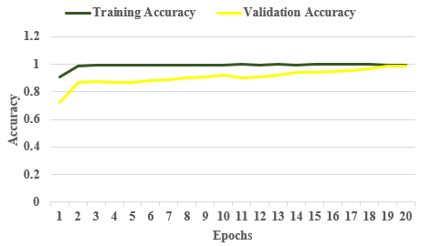
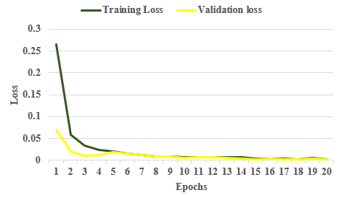
- Training -Validation Accuracy and Loss of Adam optimizer at Learning Rate of 0.0005.

- Accuracy With Different Optimizers And Learning Rates.
Optimizers | Gradient Decent |  |  | Adam
Learning Rates (LR) | 0.05 | 0.005 | 0.0005 | 0.05 | 0.005 | 0.0005
Accuracy | 95.83% | 98.45% | 98.93% | 98.45% | 99.88% | 99.91%
- Training and Validation Accuracy along Respective Loss against Each Epoch Having Learning Rate of 0.0005.
Optimizer | Adam |  |  |  | Gradient Decent
Epoch No | Training Loss | Training Accuracy | Validation loss | Validation Accuracy | Training Loss | Training Accuracy | Validation loss | Validation Accuracy
1 | 0.2661 | 0.9086 | 0.0701 | 0.7219 | 0.2361 | 0.9087 | 0.0700 | 0.0621
2 | 0.0578 | 0.9899 | 0.0201 | 0.8701 | 0.0421 | 0.9588 | 0.0302 | 0.5577
3 | 0.0341 | 0.9918 | 0.0110 | 0.8739 | 0.0421 | 0.9617 | 0.0111 | 0.8957
4 | 0.0244 | 0.9948 | 0.0117 | 0.8725 | 0.02431 | 0.9647 | 0.0116 | 0.8447
5 | 0.0199 | 0.9953 | 0.0190 | 0.8711 | 0.0198 | 0.9642 | 0.0191 | 0.8942
6 | 0.0160 | 0.9953 | 0.0156 | 0.8798 | 0.0161 | 0.9752 | 0.0155 | 0.9002
7 | 0.0117 | 0.9976 | 0.0118 | 0.8901 | 0.0112 | 0.9676 | 0.0127 | 0.9176
8 | 0.0097 | 0.9983 | 0.0095 | 0.9011 | 0.0096 | 0.9783 | 0.0078 | 0.9286
9 | 0.0093 | 0.9981 | 0.0092 | 0.9111 | 0.0093 | 0.9781 | 0.0082 | 0.9381
10 | 0.0068 | 0.9983 | 0.0062 | 0.9215 | 0.0067 | 0.9783 | 0.0071 | 0.9488
11 | 0.0076 | 0.9985 | 0.0071 | 0.9051 | 0.0066 | 0.9785 | 0.0072 | 0.9585
12 | 0.0076 | 0.9980 | 0.0068 | 0.9065 | 0.0067 | 0.9780 | 0.0057 | 0.9680
13 | 0.0065 | 0.9987 | 0.0054 | 0.9212 | 0.0064 | 0.9787 | 0.0034 | 0.9787
14 | 0.0067 | 0.9981 | 0.0047 | 0.9415 | 0.0056 | 0.9881 | 0.0047 | 0.9881
15 | 0.0040 | 0.9998 | 0.0030 | 0.9435 | 0.0040 | 0.9898 | 0.0021 | 0.9898
16 | 0.0048 | 0.9987 | 0.0040 | 0.9512 | 0.0046 | 0.9887 | 0.0041 | 0.9887
17 | 0.0046 | 0.9993 | 0.0030 | 0.9575 | 0.0046 | 0.9893 | 0.0021 | 0.9893
18 | 0.0030 | 0.9991 | 0.0023 | 0.9685 | 0.0031 | 0.9893 | 0.0032 | 0.9800
19 | 0.0059 | 0.9978 | 0.0046 | 0.9860 | 0.0058 | 0.9891 | 0.0034 | 0.9984
20 | 0.0028 | 0.9978 | 0.0028 | 0.9861 | 0.0027 | 0.9891 | 0.0034 | 0.9901

- Classification Parameters Class-wise Accuracy Parameters using Learning Rate of 0.0005.
Class | Adam optimizer |  |  |  | Gradient Decent optimizer
Class | Accuracy | Precision | Recall | F1-Score | Accuracy | Precision | Recall | F1-Score
COVID-19 | 0.99 | 0.98 | 0.99 | 0.98 | 0.96 | 0.97 | 0.98 | 0.98
Pneumonia | 0.98 | 0.97 | 0.98 | 0.98 | 0.97 | 0.99 | 0.98 | 0.96

Table V shows the class-wise accuracy, precision, recall, and F1-sore of the DSS by using two different optimizers. Adam optimizer achieved better classification parameters as compared to gradient descent. COVID cough achieved 99% accuracy and pneumonia 98% test accuracy. Precision is considered as a measurement of excellence, whereas recall can be viewed as a measurement of volume. A higher precision suggests that an algorithm provides more effective findings than superfluous ones, whereas a high recall means that an algorithm delivers the majority of accurate evidence. Precision, recall, and F1-score all are around 98% or more. Mathematically,
$Accuracy=\frac{\sum{TP+ TN}}{\sum{TP}+FP+FN+TN}$ (7)
$Precison=\frac{\sum{TP}}{\sum{TP}+FP}$ (8)
$Recall=\frac{\sum{TP}}{\sum{TP}+FN}$ (9)
$F1score=\frac{TP}{\sum{TP}+\frac{1}{2}(FP+FN)}$ (10)
Where True Positive (TP) indicates the amount of CA that has been reliably measured, True Negative (TN) notes that CA does not truly have the disease but is forecasted as yes, False Negative (FN) shows that CA truly has pulmonary diseases but is predicted no, and False Positive (FP) indicates the falsely CA envisioned by the deep learning model.
When softmax layer is given a random single image as an input, it generates a confidence value and associated label. We randomly inferenced each class sample to DSS and got the right class label against each sample as shown in Fig. 9. When random Pneumonia spectrogram is given as an input to the trained Mobilenet v2 model, it predicted it with a confidence of 98.873% with the right class label and Covid-cough with 99.048% confidence.
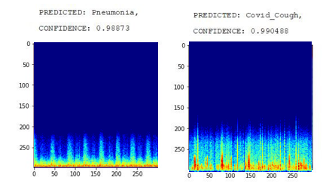
- Random Prediction During Inference.

Limitations
One major limitation of this paper is that we need more cough sounds regarding both the classes covid and pneumonia. Also, deep learning model is trained on self-collected dataset from only one country i.e., Pakistan.

Conclusion
Clinicians have consistently employed audio signals created by the human body (e.g., sighs, breathing, heart, digestion, vibration noises) as indications to diagnose a disease or monitor disease development. Till lately, these signals were often gathered by mechanical auscultation during planned visits. Digital technology is currently being utilized in research to collect physiological sounds (e.g., through digital stethoscopes) for cardiovascular or respiratory assessment, which can subsequently be used for automated methods. Some preliminary research indicates promise in identifying COVID-19 diagnostic signs in speech and coughing. In this research we present a deep learning-based decision support system with a self-designed digital sensor and self-collected dataset for covid and pneumonia coughs. We utilized coughs to determine how distinguishable COVID-19 sounds are from pneumonia ones. Our results demonstrate that the deep learning model based on Mobile net v2 and employing the transfer learning technique can properly distinguish pneumonia and COVID-19 coughs. Using the Adam optimizer, the proposed DSS obtained 99.98% training accuracy at 0.0005 learning rate, 20 epochs, and 128 batch size. These are preliminary findings that just scratch the surface of the possibilities of obtaining this type of information using audio-based deep learning. This work sets the door for future research into how digitally measured breathing/cough patterns might be used as pre-screening indications to improve COVID-19 detection. As an extended version of this article, we are aiming to explore more deep learning models and provide a comprehensive analysis between all. We also aim to implement the best deep learning model in the NVIDIA jetson nano as an end device solution for the detection and classification of pulmonary diseases. We will also analyze our system in the medical environment and engage with clinicians to learn how they utilize it and what they think about the simulations. As a result, we can enhance the models accuracy in real-time world.

Acknowledgment
This work is done under the supervision of Community of Research and Development - CRD.

References
- “COVID Live Update: 266,849,323 Cases and 5,281,054 Deaths from the Coronavirus - Worldometer.” https://www.worldometers.info/coronavirus/ (accessed Dec. 07, 2021).
- “World Health Organization.” https://www.who.int/emergencies/diseases/ novel-coronavirus-2019/question-and-answers-hub/q-a-detail/q-acoronaviruses/ (accessed Dec. 07, 2021).
- Sait, Unais, et al. "A deep-learning based multimodal system for Covid-19 diagnosis using breathing sounds and chest X-ray images." Applied Soft Computing (2021): 107522.
- Ahmad, Shandar. "Potential of age distribution profiles for the prediction of COVID-19 infection origin in a patient group." Informatics in medicine unlocked 20 (2020): 100364.
- Aziz, Sumair, et al. "An Automated System towards Diagnosis of Pneumonia using Pulmonary Auscultations." 2019 13th International Conference on Mathematics, Actuarial Science, Computer Science and Statistics (MACS). IEEE, 2019.
- D. S. Morillo, A. L. Jiménez, and S. A. Moreno, “Computer-aided diagnosis of pneumonia in patients with chronic obstructive pulmonary disease,” J. Am. Med. Inform. Assoc., vol. 20, no. e1, 2013, doi: 10.1136/AMIAJNL-2012-001171.
- Paraschiv, Elena-Anca, and Cătălina-Maria Rotaru. "Machine Learning Approaches based on Wearable Devices for Respiratory Diseases Diagnosis." 2020 International Conference on e-Health and Bioengineering (EHB). IEEE, 2020.
- Sait, Unais, et al. "A deep-learning based multimodal system for Covid-19 diagnosis using breathing sounds and chest X-ray images." Applied Soft Computing (2021): 107522.
- Chhikara, Prateek, et al. "Deep convolutional neural network with transfer learning for detecting pneumonia on chest X-rays." Advances in Bioinformatics, Multimedia, and Electronics Circuits and Signals. Springer, Singapore, 2020. 155-168.
- Horry, Michael J., et al. "COVID-19 detection through transfer learning using multimodal imaging data." IEEE Access 8 (2020): 149808-149824.
- Pal, Ankit, and Malaikannan Sankarasubbu. "Pay attention to the cough: Early diagnosis of COVID-19 using interpretable symptoms embeddings with cough sound signal processing." Proceedings of the 36th Annual ACM Symposium on Applied Computing. 2021.
- H. P. Chan, R. K. Samala, L. M. Hadjiiski, and C. Zhou, “Deep Learning in Medical Image Analysis,” Adv. Exp. Med. Biol., vol. 1213, pp. 3–21, 2020, doi: 10.1007/978-3-030-33128-3_1.
- H. Aygün and A. Apolskis, “The quality and reliability of the mechanical stethoscopes and Laser Doppler Vibrometer (LDV) to record tracheal sounds,” Appl. Acoust., vol. 161, p. 107159, Apr. 2020, doi: 10.1016/J.APACOUST.2019.107159.
- Y. hui Huang, Ying, et al. "The respiratory sound features of COVID-19 patients fill gaps between clinical data and screening methods." medRxiv (2020).
- C. Brown et al., “Exploring Automatic Diagnosis of COVID-19 from Crowdsourced Respiratory Sound Data,” Proc. ACM SIGKDD Int. Conf. Knowl. Discov. Data Min., pp. 3474–3484, Jun. 2020, doi: 10.1145/3394486.3412865.
- Imran, Ali, et al. "AI4COVID-19: AI enabled preliminary diagnosis for COVID-19 from cough samples via an app." Informatics in Medicine Unlocked 20 (2020): 100378.
- Li, Fangyu, et al. "Wi-COVID: A COVID-19 symptom detection and patient monitoring framework using WiFi." Smart Health 19 (2021): 100147.
- Khan, Misha Urooj, et al. "A Novel Intelligent Model For COVID-19 Detection Using Cough Auscultations and Hjorth Descriptors." ICAME21, International Conference on Advances in Mechanical Engineering, Pakistan. 2021.
- M. U. Khan, A. Farman, A. U. Rehman, N. Israr, M. Z. H. Ali and Z. A. Gulshan, "Automated System Design for Classification of Chronic Lung Viruses using Non-Linear Dynamic System Features and K-Nearest Neighbour," 2021 Mohammad Ali Jinnah University International Conference on Computing (MAJICC), 2021, pp. 1-8, doi: 10.1109/MAJICC53071.2021.9526272.
- Khan, Misha Urooj, et al. "Embedded System Design for Real-time Detection of Asthmatic Diseases Using Lung Sounds in Cepstral Domain." 6th International Electrical Engineering Conference (IEEC 2021) April, 2021 at NEDUET. 2021.
- L. Khriji, A. Ammari, S. Messaoud, S. Bouaafia, A. Maraoui and M. Machhout, "COVID-19 Recognition Based on Patient's Coughing and Breathing Patterns Analysis: Deep Learning Approach," 2021 29th Conference of Open Innovations Association (FRUCT), 2021, pp. 185-191, doi: 10.23919/FRUCT52173.2021.9435454.
- Vijayakumar, D. Sudaroli, and Monica Sneha. "Low cost Covid-19 preliminary diagnosis utilizing cough samples and keenly intellective deep learning approaches." Alexandria Engineering Journal 60.1 (2021): 549-557.
- Zhu, Ziwei, et al. "Classification of COVID-19 by compressed chest CT image through deep learning on a large patients cohort." Interdisciplinary Sciences: Computational Life Sciences 13.1 (2021): 73-82.
- Zhou, Min, et al. "Deep learning for differentiating novel coronavirus pneumonia and influenza pneumonia." Annals of Translational Medicine 9.2 (2021).
- Maghdid, Halgurd S., et al. "Diagnosing COVID-19 pneumonia from X-ray and CT images using deep learning and transfer learning algorithms." Multimodal Image Exploitation and Learning 2021. Vol. 11734. International Society for Optics and Photonics, 2021.
- S. Z. H. Naqvi, M. Arooj, S. Aziz, M. U. Khan, M. A. Choudhary and M. N. ul. Hassan, "Spectral Analysis of Lungs sounds for Classification of Asthma and Pneumonia Wheezing," 2020 International Conference on Electrical, Communication, and Computer Engineering (ICECCE), 2020, pp. 1-6, doi: 10.1109/ICECCE49384.2020.9179417.
- Zhang, Hai-tao, et al. "Automated detection and quantification of COVID-19 pneumonia: CT imaging analysis by a deep learning-based software." European journal of nuclear medicine and molecular imaging 47.11 (2020): 2525-2532.
- A. Serener and S. Serte, "Deep learning for mycoplasma pneumonia discrimination from pneumonias like COVID-19," 2020 4th International Symposium on Multidisciplinary Studies and Innovative Technologies (ISMSIT), 2020, pp. 1-5, doi: 10.1109/ISMSIT50672.2020.9254561.
- El Asnaoui, Khalid, and Youness Chawki. "Using X-ray images and deep learning for automated detection of coronavirus disease." Journal of Biomolecular Structure and Dynamics (2020): 1-12.
- Yildirim, Muhammed, and Ahmet Cevahir Cinar. "A Deep Learning Based Hybrid Approach for COVID-19 Disease Detections." Traitement du Signal 37.3 (2020): 461-468.
- Zhou, Min, et al. "Improved deep learning model for differentiating novel coronavirus pneumonia and influenza pneumonia." medRxiv (2020).
- Alazab, Moutaz, et al. "COVID-19 prediction and detection using deep learning." International Journal of Computer Information Systems and Industrial Management Applications 12 (2020): 168-181.
- P. Mouawad, T. Dubnov, and S. Dubnov, “Robust Detection of COVID-19 in Cough Sounds: Using Recurrence Dynamics and Variable Markov Model,” SN Comput. Sci., vol. 2, no. 1, Feb. 2021, doi: 10.1007/S42979-020-00422-6.
- M. Melek, “Diagnosis of COVID-19 and non-COVID-19 patients by classifying only a single cough sound,” Neural Comput. Appl., vol. 33, no. 24, pp. 17621–17632, Dec. 2021, doi: 10.1007/S00521-021-06346-3.
- M. A. Kobat et al., “Automated COVID-19 and Heart Failure Detection Using DNA Pattern Technique with Cough Sounds,” Diagnostics, vol. 11, no. 11, p. 1962, Oct. 2021, doi: 10.3390/DIAGNOSTICS11111962.
- “ImageNet.” https://www.image-net.org/ (accessed Sep. 10, 2021).
- F. Zhuang et al., “A Comprehensive Survey on Transfer Learning,” Proc. IEEE, vol. 109, no. 1, pp. 43–76, Jan. 2021, doi: 10.1109/JPROC.2020.3004555.
- K. Dong, C. Zhou, Y. Ruan, and Y. Li, “MobileNetV2 Model for Image Classification,” Proc. - 2020 2nd Int. Conf. Inf. Technol. Comput. Appl. ITCA 2020, pp. 476–480, Dec. 2020, doi: 10.1109/ITCA52113.2020.00106.
- M. Sandler, A. Howard, M. Zhu, A. Zhmoginov, and L. C. Chen, “MobileNetV2: Inverted Residuals and Linear Bottlenecks,” Proc. IEEE Comput. Soc. Conf. Comput. Vis. Pattern Recognit., pp. 4510–4520, Dec. 2018, doi: 10.1109/CVPR.2018.00474.
- Z. Zhang, “Improved Adam Optimizer for Deep Neural Networks,” 2018 IEEE/ACM 26th Int. Symp. Qual. Serv. IWQoS 2018, Jan. 2019, doi: 10.1109/IWQOS.2018.8624183.
- D. Gong, Z. Zhang, Q. Shi, A. Van Den Hengel, C. Shen, and Y. Zhang, “Learning Deep Gradient Descent Optimization for Image Deconvolution,” IEEE Trans. Neural Networks Learn. Syst., vol. 31, no. 12, pp. 5468–5482, Dec. 2020, doi: 10.1109/TNNLS.2020.2968289.
- M. U. Khan, S. Samer, A. Samer, A. Mobeen, A. Arshad, and H. Khan, “Classification of Phonocardiography based Heart Auscultations while Listening to Tilawat-e-Quran and Music Using Vibrational Mode Decomposition,” 2021 Int. Conf. Appl. Eng. Math., pp. 25–30, Aug. 2021, doi: 10.1109/ICAEM53552.2021.9547150.
- M. U. Khan, H. Khan, M. Muneeb, Z. Abbasi, U. B. Abbasi, and N. K. Baloch, “Supervised Machine Learning based Fast Hand Gesture Recognition and Classification Using Electromyography (EMG) Signals,” 2021 Int. Conf. Appl. Eng. Math., pp. 81–86, Aug. 2021, doi: 10.1109/ICAEM53552.2021.9547148.
- M. U. Khan, A. Mobeen, S. Samer, and A. Samer, “Embedded System Design for Real-time Detection of Asthmatic Diseases Using Lung Sounds in Cepstral Domain,” in 6th International Electrical Engineering Conference (IEEC 2021) April, 2021 at NEDUET, Karachi, Pakistan, 2021, pp. 1–6, [Online]. Available: https://ieec.neduet.edu.pk/2021/papers_2021/IEEC_2021_18.pdf.

