Azimuth Angle and Magnetic Declination to Maximize Solar Panel Efficiency (Solar Tracking System)

Waseem Shehzad
Department of Electrical Engineering
University of Engineering and Technology
Taxila, Rawalpindi, Pakistan
waseemshehzad1998@gmail.com
Syeda Zuriat e Zehra Ali
Department of Electrical Engineering
University of Engineering and Technology
Taxila, Rawalpindi, Pakistan
zuriat2215@gmail.com
Asad Ur Rehman
Department of Electrical Engineering
University of Engineering and Technology
Taxila, Rawalpindi, Pakistan
chaudharyasad95@gmail.com
Shah Zaman
Department of Electrical Engineering
University of Engineering and Technology
Taxila, Rawalpindi, Pakistan
shahzamanbwp@gmail.com

Zubair Saeed
Department of Computer Engineering
University of Engineering and Technology
Taxila, Rawalpindi, Pakistan
zubairsaeed602@gmail.com
Faheem Shehzad
Department of Computer Science
COMSATS University Islamabad, Wah Campus
Wah Cantt, Pakistan
farishehzad92@gmail.com

Abstract— This study presents the idea of power production through the solar which depends on the light intensity that falls on the solar panel. This project utilizes dual axis solar tracking system based on intensity of light using Arduino UNO. The hardware implementation includes an Arduino UNO and four LDR sensor for sensing the maximum intensity of light. Two DC motors are used, one motor is used for horizontal rotation and the second motor is used for the vertical rotation. This system includes the implementation of MPPT. It controls the charge and stores it in a battery. Battery provides 12V to inverter where DC voltages convert into AC voltages. SPWM inverter is designed over push pull topology. In conclusion, the proposed system operates on low input power and delivers high efficiency in output.

Keywords- Dual Axis, Solar tracking system, inverter, MPPT, Arduino.

Introduction
As the time is progressing, the energy demand is increasing. Previously, the demand of energy was fulfilled through the fossil fuels which is used in the electric power generation but due to the environmental hazards of fossil fuel i.e. Pollution, their use has decreased [1]. This had forced man to find the alternative ways to overcome the demand. Renewable Energy obtained from various sources like wind, water and solar is now used to generate electric power since it is more cost-effective and economical [2]. Now the world is moving towards solar energy as it is the common Distributed Generation (DG) installed in rooftops. This is because the sunlight is always available for the maximum time [3].
Pakistan is facing serious energy crisis due to which renewable energy demand is increasing in our country [4]. The world is moving towards solar energy as it is the most commonly used distributed generation installed in every rooftop. Also, Pakistan is one of the countries of the world where sunlight is available for the maximum time [5]. As a result, the project's goal is to improve solar panel efficiency. Inverter is used to convert the DC voltages to AC voltages [6]. As we know our home appliances are worked on AC voltages [7]. So, for this purpose we used the SPWM inverter. SPWM inverter topology has the maximum efficiency in comparison to other topologies [8].
The benefit of this design is that it maximizes the solar panel efficiency which will reduce the number of solar panels for operation purposes [9]. The solar tracker has been designed in this project which helps in positioning the solar panel in the direction of sun so that highest number of photons strikes on the panel [10]. As a result, maximum solar energy is utilized for generation of electricity [11].
A two-axis solar tracker was constructed in one of the research projects in Ref. [12], and the tracking was done according to the sun's longest route. Under cloudless clear weather, the system was shown to produce 42.6 percent more energy than a stationary PV system [12]. Other experiments using a two-axis solar tracker found similar results, with the greatest percentage of energy gathered being 41.34 percent greater as compared to fixed PV system [13], [14]. Even a single axis device [15] has the potential to gather 22% higher energy than with a fixed PV system. One of the experiments looked at current, voltage, and power with resistance change, and found that the recorded power increase for two-axis was 43.87 percent, for east-west tracking it was 37.53 percent, for vertical tracking 34.43 percent, and 15.69 percent for north-south tracking. The control and motor system utilized less than 2% of the total energy gathered [16]. To maximize the collection of energy, an open-loop tracking system based on neuro-fuzzy systems was also built [17]. In [18, 19], an algorithm was developed for a low-cost, high-precision, closed-loop sun-tracking system. The basic reason is that doing trials on real-time technologies are just too costly [20-22]. To solve the problem of tracking system of sun some studies [23–26] use microcontrollers and dc motors programmed through MATLAB. The authors developed a prototype of the portable technology that may be used to deploy solar panels [31-33].
In this paper we focused on angle and magnetic declination to maximize solar panel efficiency. We mainly focused on dual axis solar tracking scheme which depends on intensity of light using Arduino UNO. The next portion highlights that the proposed system operates on low input power as well as it delivers high output efficiency.

aims and objectives
Pakistan is one of the countries where sunlight is available for maximum time. Because the orientation of the sun changes over time, the solar panel must be set in such a way that it captures the maximum quantity of photons. So, our objective is to produce maximum power by using a smaller number of panels. Therefore, a solar tracker is designed which helps in moving the panel with respect to the position of sun to produce maximum power.
Main block diagram of our project is shown in figure 1:
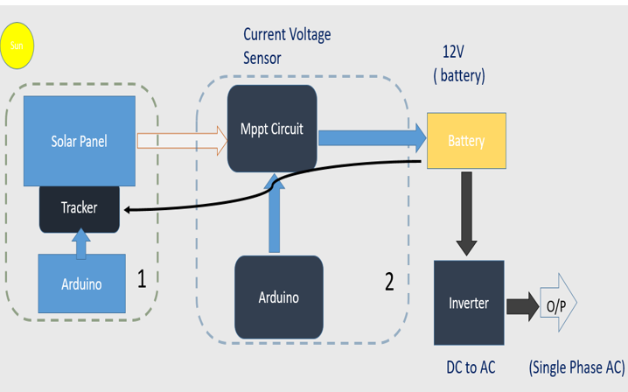
Figure 1. Block Diagram

Design of Hardware

Solar Panel And Tracking
In this form of tracker, the tracker just follows one path. Either horizontal or vertical axis is used for tracking the sun path. In equatorial areas, horizontal tracking system is used and in laxity regions, vertical tracking system is used. In this tracker, both horizontal axis which move the solar panel upward, down word direction and vertical axis which makes the panel to move parallel to the ground are used. Here two types of angles azimuth angle and elevation angles are used to determine the direction of sun. By using these angles, we get the better accuracy to find the maximum position of sun. Dual axis tracking system accuracy is about double times greater than the single axis tracker. In our project, we are using dual axis tracking system. By using this system, we will get the better results than the single axis designing [28].
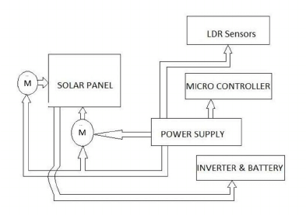
Figure 2. Diagram of solar tracking system
DC Gear Motor conductor which carried the current is placed in the magnetic field than in the specific direction, a force is experienced. Let’s now there is a simple model of DC motor, a single turn of conductor is put between two opposite polarities of poles, one is the south pole and the second is the north pole as we can see in the figure. Now if through the commutator we applied DC current to the turn than current becomes start to flow through it. Now the batteries positive terminal is connected with the left conductor side and right conductor side of the turn is connected to the negative terminal of the battery. Also, we can see in this model that at the left position side magnetic south pole is placed and at right side position north pole is present. Current flows inwards in the left side of the conductor and flows outwards from the terminal in right-side of conductor. One can use Fleming’s left-hand rule, where findings show that the position of force. To do so, we must have to stretch left hand's fourth thumb and fingers by the right angle towards each other. If four fingers are lined along the magnetic field direction (north pole to south pole) and the second or middle finger is positioned along the force direction. This is clearly upward here. Similarly, again the four fingers aligned as of north pole towards south pole plus second finger or middle finger is connected along the current direction in the right-side conductor so now the thumb indicates the mechanical force direction. This is totally downward. Due to these upward and downward forces on the turn, one torque is produced which tends to rotate turn in clockwise direction. After clockwise direction of rotation of 90-degree turns come towards the vertical position in respect of the magnetic field [27].
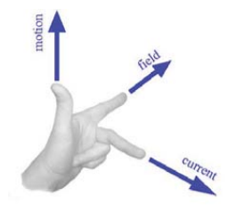
Figure 3. Fleming's left-hand rule

Tilt angle tracking
As the N-S movement of sun everyday daily sun every day is very tiny, it is not worth to perform the tracking continuously on the tilt angle side. Several studies have revealed that a small number of movements each year, between four and eight, is likely more than adequate to extract more than 98 percent of the energy. Fig. 4. shows the position of the PANEL with relation to the sun. The resultant current is given by Eq. (1) if the elevation angle is about geographical north (not magnetic north).
I= I₀Cos $θ$ (1)
When the panels are perpendicular to the irradiation, then the combination of current (I) is equals to the product of the inclination angle (Cos $θ$) and maximum current (I₀). In Bahrain, the difference in tilt angle is roughly 35.5°C between summer and winter. Because the shift in angle over each season is less than 15°C, online tracking is unlikely to be beneficial. This may not have a significant impact on energy extraction. Off-line tracking, on the other hand, is helpful when the tilt angle is only modified four or at most eight times a year [28].
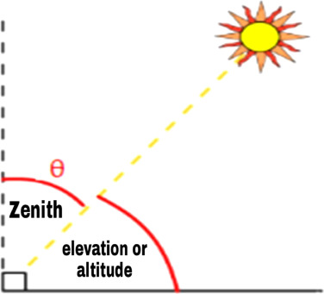
Figure 4. Elevation of PANEL with respect to the sun

MPPT
Makes the output voltage step down. The buck converter is a straightforward kind of DC-DC converter that delivers a yield voltage that is not as much as its information. It is normally utilized when input is high as compared to output battery bank. MPPT configuration must be originated on the structure of the PV context. On the off chance that the battery bank voltage is equivalent or under 48V, buck converter will be utilized. On the off chance that the battery bank voltage is more prominent than 48V, step up converter will be the best alternative.
We are using Perturb and Observe method for MPPT designing. P&O Method Is a general Cost-Effective Solution for MPPT [29]. The block diagram of perturb and observe method is shown below:
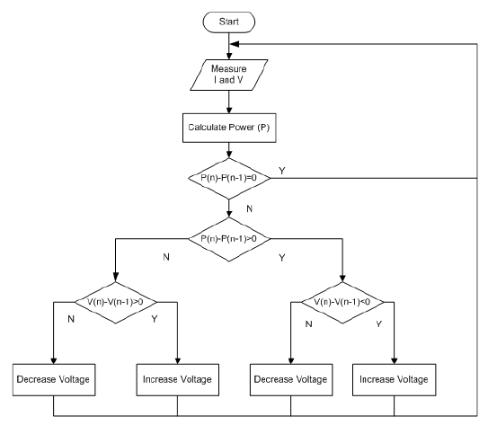
Figure 5. P & O Algorithm

Inverter
Inverter is the circuit which is utilized for conversion of DC voltages to AC voltages. Inverter is now essential part of the industry because it is used in many devices, UPS, and variable frequency devices. In our project design we are using H-Bridge topology. It is commonly used topology [30].
Arduino UNO is used for PWM output. BC547 is used to generate the signal. Couple of BC547 generating antiphase signal which further proceed to TIP142. TIP142 are used for switching they generate a wave like sine wave having some noise which is later removed. TIP142 is center tap transformer. Its primary winding is divided into two parts so two different voltages can be acquired. It takes input from TIP142 and gives step up output which is further filtered.
The output of the inverter is distorted so we use filters to convert the wave into sine wave. In our Project we use LC filter. Filter will remove the harmonics from the output ac voltage of our inverter. Then the wave will be converted into a sine wave. With the use of a step up transformer, the converted sine wave is then step up to obtain a voltage of 220 volts rms.

Software
This includes software design of our work. With the help of software tool, first of all we make our designs on the software and check the working of our circuits. After getting the results from software work than we proceed further for the hardware design for our hardware work. Software’s that we used during our work are as follows.
- Arduino
- Proteus.

Solar Tracker
The first part of our project is the solar tracker. We implement the solar tracker on the software with the help of coding. We will read the 4-LDR values through the analog pins of Arduino and a PWM is generated according to the analog inputs all these will be happen through the coding.
LDR1 starts operating as the light declines on sensor1. Then the output of LDR1 goes to the Arduino pin A0 and then from the pin5, signal makes the horizontal motor active through the relay1. So, the horizontal motor starts rotating from left side to the right side.
Correspondingly, LDR2 sensor operates and then output goes to the pin A1 of the Arduino UNO. Then through the pin4, horizontal motor starts moving from right side to the left side. The same procedure is followed by the LDR3 and LDR4. Here the vertical DC motor starts rotating from left side to the right side for sensor3 and for sensor4 vertical DC motor starts rotating from right side to the left side.
Arduino will generate the PWM according to that and move the panel to the left position with the help of motor. On the other hand, if the right LDR has greater intensity of light than the left LDR. Now the voltage appeared across the right LDR is greater and Arduino will rotate panel toward right position.
In any case if light is falling on the all LDR’s with same intensity than their voltage will also be equal and Arduino will not rotate the motor and our panel is at its position.
To control the direction of DC motor we use Arduino uno in the above software design. Arduino will read the values of these sensors in the form of voltages and then according to that it will turn on the Specific Relay according the sensors. Simulation of dual axis solar tracker is shown in figure.6:
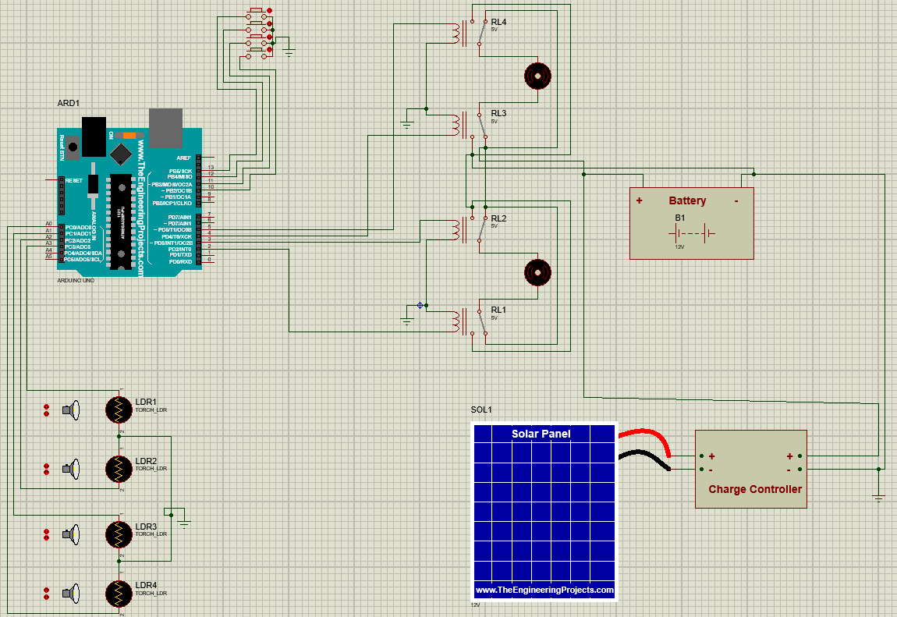
Figure 6. Dual axis solar tracker simulation

MPPT
The main idea on which MPPT functions is to withdraw most accessible power from the photovoltaics modules. The MPPT compares the yield of PV modules to that of the battery and switches it to the most appropriate voltage for charging the battery and to the optimum yield control to obtain the most extreme current into the battery. MPPT can be utilized to supply capacity to the DC load which some time is legitimately associated with the battery. MPPT is basically a type of DC-to-DC converter which intake DC for sun-based panel. it changes over it to various DC voltage and current dimension which will be coordinating with the voltage and current of the battery bank. Simulation of MPPT is shown in figure.7:
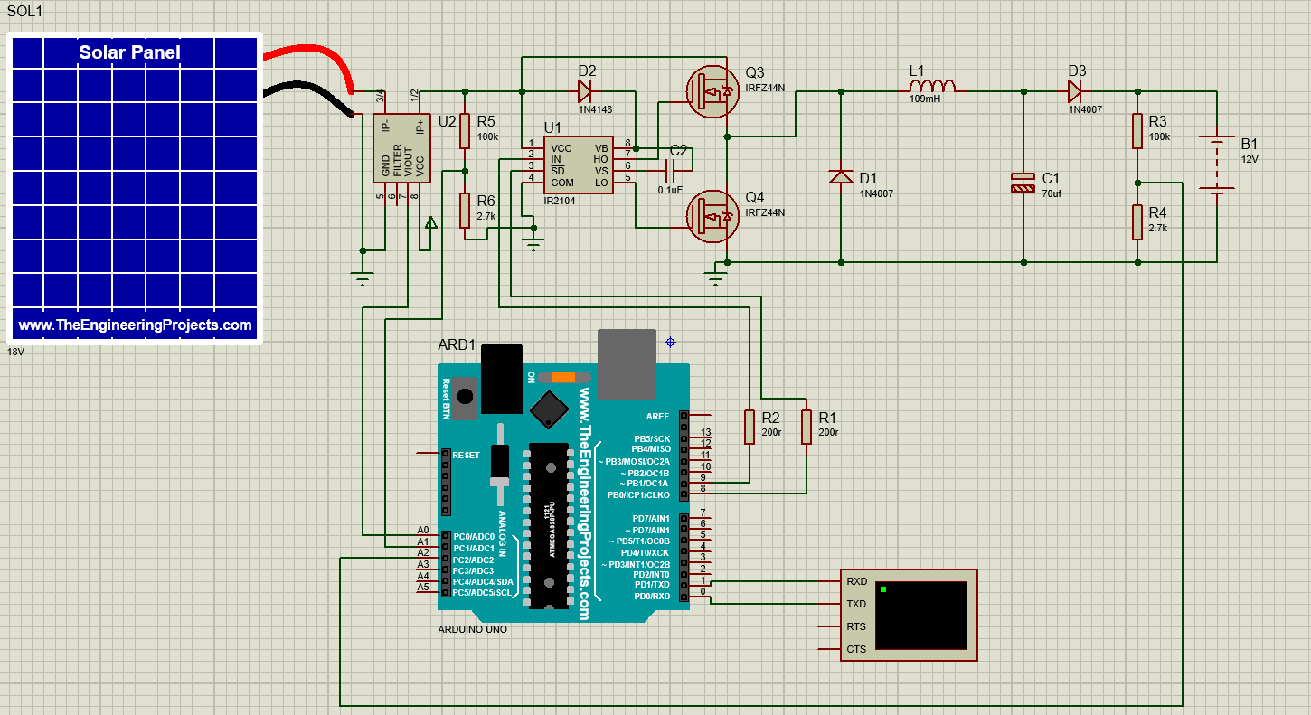
Figure 7. MPPT Simulation

Inverter
In inverter design we will focus on two things. First one is inverter type and the second is gating signal for the inverter.
This technique is the best one as compared to above techniques. With the help of this technique the output waveform of our inverter will be same as the grid’s waveform. Multiple pulses with different time period have been generated in a half cycle of time period.
We generated the SPWM signal with the help of digital method. There is also second method. But digital technique is better technique. Digital technique is more flexible, we can make any change with the help of coding.
Inverter converts DC to AC. Microcontroller is producing the SPWM signal. Gate driver IC’s are used for strengthen the gating signal of MOSFET that is produced by microcontroller. Step-Up Transformer is used to convert the output of Inverter (12V-AC) to 220V-AC. Filter is used to remove harmonics from the output. Simulation of inverter is shown in figure.8:
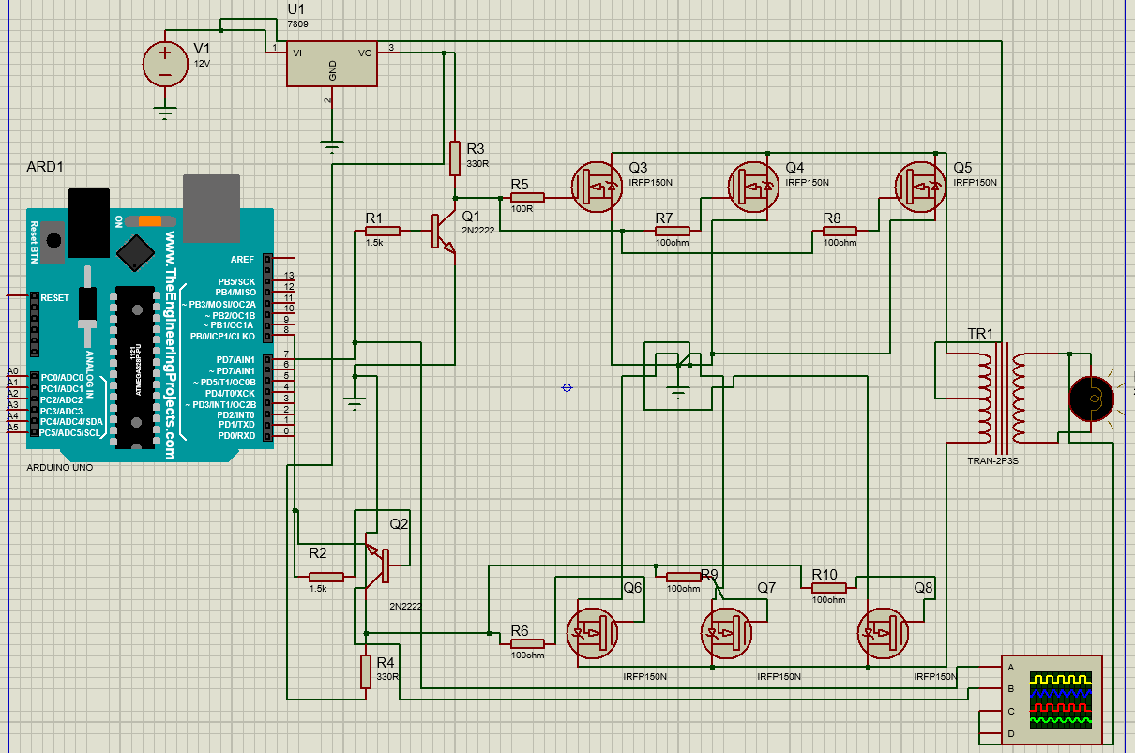
Figure 8. Inverter simulation

Results

Simulation Inverter Result
Our simulation was performed on PROTEUS software for the final software implementation.
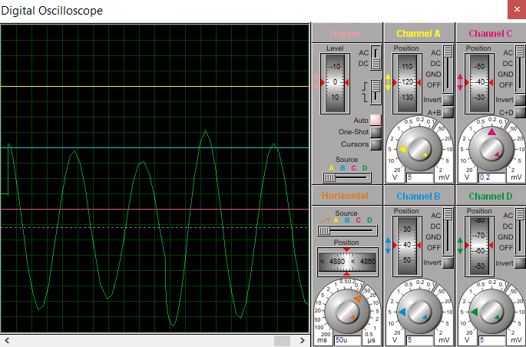
Figure 9. Inverter Output
This is the output of ARDUINO which generate pulses. From output we can see that if we increase duty cycle then the voltage also increases. By using several pulses in a half cycle the harmonic content can be reduced in our output voltage. It can also be seen that the output waveform is purified sine wave. By raising the switching frequency and width of the SPWM signal, the output can be made more sinusoidal.

MPPT Simulation Result
MPPT is used for charging the battery and to improve the efficiency of PV array output power.
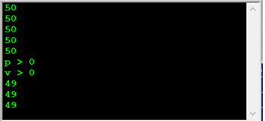
Figure 10. MPPT Output

Practical Inverter Result
The practical output waveform of the designed inverter is shown in figure.11.

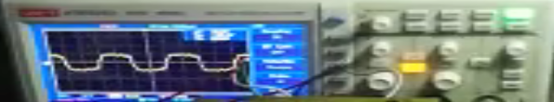
Figure 11. Output of Inverter

By employing an inverter, the 12 V DC output from the battery is now converted to 220 V AC voltages. Push pull topology is used in the design of the modified SPWM inverter. The center tap transformer MOSFET and BJT are used to convert DC voltages.

Output Comparison Of Tracking System
We noticed the varying values of power of fixed, single axis, and dual axis systems at different times utilizing table.1.
Table 1: Power (watts) of 3 systems at different times
Timing | Fixed System (P in Watts) | Single axis System (P in Watts) | Dual axis System (P in Watts)
7:00 am | 0.09 | 0.3 | 0.32
7:20 am | 0.1 | 0.32 | 0.35
7:40 am | 0.11 | 0.36 | 0.37
8:00 am | 0.14 | 0.4 | 0.42
8:20 am | 0.7 | 2.6 | 6.4
8:40 am | 1.45 | 3 | 9.64
9:00 am | 1.86 | 3.53 | 11.45
9:20 am | 5.73 | 9.46 | 14.24
9:40 am | 9.45 | 13.89 | 17.35
10:00 am | 12.8 | 16.3 | 20.2
10:20 am | 13.6 | 17.5 | 20.9
10:40 am | 14.7 | 17.9 | 21.04
11:00 am | 15.8 | 18.38 | 21.4
11:20 am | 15.82 | 18.4 | 21.52
11:40 am | 15.85 | 18.41 | 21.61
12:00 pm | 15.87 | 17.95 | 21.69
12:20 pm | 15.98 | 17.99 | 22.29
12:40 pm | 16.14 | 18.25 | 22.94
13:00 pm | 16.30 | 18.7 | 23.2
14:00 pm | 14.35 | 18.4 | 22.15
15:00 pm | 14.4 | 17.65 | 21.2
16:00 pm | 10.5 | 14.8 | 18.95

Without load output voltage = 21.5 V
With load output voltage = 18V
With load current = 1.67 Ampere
We can see that the values obtained from the dual axis solar tracker are bigger than those obtained from the fixed and single axis tracking systems by comparing the values. Also, we conclude that during the morning time and after 3 pm, fixed and single axis system does not provide sufficient power to fulfill our desire required values but on the other side, dual axis solar system during the maximum of the daytime provide enough power which we are needed.

Limitations
- We cannot achieve 100% pure sine wave through inverter; therefore, it will have some harmonics.
- Any equipment which converts DC to AC loses power during the process of conversion. Let’s say if an inverter is 80% efficient, it means that 20% of power is lost during conversion process.

Conclusion
In precise terms this project’s objective is to have a sunlight-based board yielding its most extreme conceivable power constantly, this is accomplished by tracking the sun and turning the sunlight-based board in the same manner, allowing daylight to reach the farthest areas of the daytime. In this task we found out about parameters affecting vitality transformation of Photovoltaic (PV) exhibits. Likewise Learned about the over-all idea of Maximum Power Point Tracking (MPPT) and how to program consume an Arduino. In any case, proficiency and molded yield control is yet a major valuation for analysts and PV industry. Power streamlining technique assumes an energetic job in the execution of the sunlight-based photograph voltaic frameworks. Double pivot sunlight-based tracker ensures the greatest coupling of the sun with the sun powered module that expands the sun-based efficiency. The proposed Perturb and Observe calculation is the change in the regular calculation that limits the hunt space of the calculation diminishing the multifaceted nature and improving the execution of the traditional calculation under uniform and differing climate conditions.

References
- ''I-Vcurve for solar panels'', Retrieved from https://www.researchgate.net/figure/P-V-curve-for-different-solar-irradiance-The-simulation-result-of-I-V-and-P-_fig1_295857541, [Last accessed 20 March 2019]
- R. Radharamanan and J. N. Juang "Design of a Solar Tracking System for Renewable Energy," Conference of the American Society for Engineering Education, pp. 1-8, ASEE, 2014..
- N. Barsoum, Nader and P.Vasnat "Simplified Solar Tracking Prototype,"Global Journal of Technology and Optimization , vol. 1, pp. 38-45, 2010.
- Arash, Shafiei and S. S. Williamson "A novel Pholovoltic MPPT for battery charging applications,"25th IEEE Canadian Conference on Electrical and Computer Engineering, 2012.
- Resistance vs Light Anxiety Graph", Retrieved from: https://etechnophiles.com/ ldr-working-how-an-ldr-or-photoresistor-works/how_alight_depedant_resistor_works_resistance_v_light_intensity/, [Last accessed 10 April 2019]
- DC Motor Control", Retrieved from http://hyper-physics.phy-astr.gsu.edu/ hbase/ magnetic/motdc.html, [Last accessed 6 April 2019]
- "Main diagram of Solar Tracking System", Retrieved from https:// www.research-gate.net/figure/Block-diagram-of-regulating-a-solar-tracker_fig1 _264979033, [Last accessed 5 April 2019
- Characteristic curve" Retrieved from: https://www.electrical-4u.com-/-light-dependent-resistor-ldr-working-principle-of-ldr/,[Last accessed 10 April 2019]
- P & O Algorithm", Retrieved from: https://www.mdpi.com/ 1996-1073/ 10/ 9/ 1316 /htm, [Last accessed 10 April 2019]
- Y. Jiang and A. Qahouq, "MPPT Control and Architecture for PV Solar Panel with Sub-Module Integrated Converters," Journal of Power Electronics, vol. 14, no. 6, pp. 1281-1292, 2014
- Abdelhakim, Belkaid, K.Kayisli and Ilhami Colak, "Implementation of a modified P&O-MPPT algorithm adapted for varying solar radiation conditions," Electrical Engineering, vol.99, no.3, pp. 839-846, 201
- Sungur, C., 2009. Multi-axes sun-tracking system with PLC control for photovoltaic panels in Turkey. Renewable energy, 34(4), pp.1119-1125.
- Al-Soud, M.S., Abdallah, E., Akayleh, A., Abdallah, S. and Hrayshat, E.S., 2010. A parabolic solar cooker with automatic two axes sun tracking system. Applied Energy, 87(2), pp.463-470.
- Abdallah, S. and Nijmeh, S., 2004. Two axes sun tracking system with PLC control. Energy conversion and management, 45(11-12), pp.1931-1939.
- Abdallah, S. and Badran, O.O., 2008. Sun tracking system for productivity enhancement of solar still. Desalination, 220(1-3), pp.669-676.
- Abdallah, S., 2004. The effect of using sun tracking systems on the voltage–current characteristics and power generation of flat plate photovoltaics. Energy conversion and management, 45(11-12), pp.1671-1679.
- Alata, M., Al-Nimr, M.A. and Qaroush, Y., 2005. Developing a multipurpose sun tracking system using fuzzy control. Energy Conversion and Management, 46(7-8), pp.1229-1245.
- Chowdhury, M.E., Khandakar, A., Hossain, B. and Abouhasera, R., 2019. A low-cost closed-loop solar tracking system based on the sun position algorithm. Journal of Sensors, 2019.
- Charafeddine, K. and Tsyruk, S., 2020, September. Automatic Sun-Tracking System. In 2020 International Russian Automation Conference (RusAutoCon) (pp. 191-195). IEEE.
- A. U. Rehman, M. U. Khan, M. Z. H. Ali, M. S. Shah, M. F. Ullah and M. Ayub, "Stability Enhancement of Commercial Boeing Aircraft with Integration of PID Controller," 2021 International Conference on Applied and Engineering Mathematics (ICAEM), 2021, pp. 43-48, doi: 10.1109/ICAEM53552.2021.9547186.
- M. U. Khan, A. Farman, A. U. Rehman, N. Israr, M. Z. H. Ali and Z. A. Gulshan, "Automated System Design for Classification of Chronic Lung Viruses using Non-Linear Dynamic System Features and K-Nearest Neighbour," 2021 Mohammad Ali Jinnah University International Conference on Computing (MAJICC), 2021, pp. 1-8, doi: 10.1109/MAJICC53071.2021.9526272.
- Khan, Misha Urooj, et al. "Nanoscale CMOS Scaling Trends, Challenges and Their Solutions." ICAME21, International Conference on Advances in Mechanical Engineering, Pakistan. 2021.
- Zulkafli, R.S., Bawazir, A.S., Amin, N.A.M., Hashim, M.S.M., Majid, M.S.A. and Nasir, N.F.M., 2018. Dual axis solar tracking system in Perlis, Malaysia. Journal of Telecommunication, Electronic and Computer Engineering (JTEC), 10(1-14), pp.91-94.
- Sharma, Priyanjan, and Nitesh Malhotra. "Solar tracking system using microcontroller." 2014 1st International Conference on Non Conventional Energy (ICONCE 2014). IEEE, 2014.
- Singh, A. and Aphiratsakun, N., 2015, June. AU solar tracking system. In 2015 12th International Conference on Electrical Engineering/Electronics, Computer, Telecommunications and Information Technology (ECTI-CON) (pp. 1-4). IEEE.
- Kassem, Abdallah, and Mo Hamad. "A microcontroller-based multi-function solar tracking system." 2011 IEEE International Systems Conference. IEEE, 2011.
- A. Aktaibi, W. D. Hoffman and R. L. Hall, "Design and Testing of Magnetohydrodynamic Propulsion System for a Small Vessel Using Powdered Iron Core Electromagnets," 2019 IEEE Canadian Conference of Electrical and Computer Engineering (CCECE), 2019, pp. 1-4, doi: 10.1109/CCECE.2019.8861567.
- Ghassoul, M., 2021. A dual solar tracking system based on a light to frequency converter using a microcontroller. Fuel Communications, 6, p.100007.\
- Rastogi, M., Ahmad, A. and Bhat, A.H., 2021. Performance investigation of two-level reduced-switch D-STATCOM in grid-tied solar-PV array with stepped P&O MPPT algorithm and modified SRF strategy. Journal of King Saud University-Engineering Sciences.
- Salimi, M., Radmand, F. and Firouz, M.H., 2021. Dynamic Modeling and Closed-loop Control of Hybrid Grid-connected Renewable Energy System with Multi-input Multi-output Controller. Journal of Modern Power Systems and Clean Energy, 9(1), pp.94-103.
- A. Ur Rehman, M. U. Khan, M. S. Shah, Q. Maqsood, M. F. Ullah and S. Uba, "Aircraft Pitch Control based on Genetic Algorithm Tuning with PID and LQR Controller," 2021 6th International Multi-Topic ICT Conference (IMTIC), 2021, pp. 1-6, doi: 10.1109/IMTIC53841.2021.9719736.
- A. Ur Rehman, M. U. Khan, M. T. Rehman, W. Shehzad, S. Zaman and M. W. Khan, "Mathematical Modelling and Implementation of 2DOF Standard, Parallel & Series PID Controllers," 2021 6th International Multi-Topic ICT Conference (IMTIC), 2021, pp. 1-6, doi: 10.1109/IMTIC53841.2021.9719800.
- M. U. Khan, A. Shaheen, M. Zeeshan, Asad-ur-Rehman, M. Adnan and M. T. Rehman, "Real-Time Design of HMI for Hazardous Gas Control and Monitoring System in Pakistani Mines, Natural Gas Areas and Fertilizer Plants," 2021 6th International Multi-Topic ICT Conference (IMTIC), 2021, pp. 1-6, doi: 10.1109/IMTIC53841.2021.9719710.

